

**Cairo University**

**Faculty of Graduate Studies for Statistical Research**

**Department of Computer Sciences**

**TeleGo**

**Submitted by**

**Ahmed Adel Abdel Hameed Abdel Aziz El Sabagh** (C.S. Department)

**Mariam Mohamed Mostafa** (C.S. Department)

**Mohamed Mahmoud Mahnie Gewaly** (C.S. Department)

**Supervised by**

##### Dr. [Nesrine Ali](https://www.facebook.com/nesrine.ali.165?fref=gs&__tn__=%2CdlC-R-R&eid=ARDenjh5NvsNCRm0grtfhIUDTIlCf0n4kNeaN4_d7wHyZWe-QBlbDvYCPmsE1fdDjjDzIl7XAfRQmCf-&hc_ref=ARQUhAl38wjrlM5iPZZoEBRBwpe0Y3JB9X_wI3yKgXGBRVkpNMvfOP3xmTH3jvnY0Vs&ref=nf_target&dti=2382644288499837&hc_location=group)

Cairo, Egypt

June 2020

**Acknowledgement**

At the beginning and at the end we all thank Allah for helping us to achieve this work and ask Allah to benefit us with what he taught us and teach us what will benefit us.

Also the achievement of this piece of work wouldn’t be to see the light without the support,

Doctor: Nesrine Ali supervisor of our graduation project. All the faculty members who taught us during our study in the degree program. Finally we thank our families for supporting us and helped us to reach so far and to have the tolerance to face difficulties and keep up.

**Abstract**

TeleGo is a solution that has a great advantage of approaching people and places magically, a great feature is added into it, it is connecting people with each other based on not only their geographical location but also by their preferences and common interests.

User will be able to define a new relation or a label or any valid searchable criteria.

Then other users will be able to search for their interests in a nearby location.

System enables users to parametrically filter searchable criteria across all defined ones.

**Certification**

We certify that this work has not been accepted in substance for any academic degree and is not being concurrently submitted in candidature for any other degree. Any portions of this thesis for which we are indebted to other sources are mentioned and explicit references are given.

**Table of content**

**Chapter1: Introduction….......................……...................2**

1.1. Introduction……………………………..……..2

1.2. Project objectives…………………………..…..2

1.3. Problem Definition…………………………..…3

1.4. Previous Work……………………………..…..4

**Chapter 2: Requirement analysis……............................15**

2.1. Requirements elicitation……………….………8

2.1.1. Resources…………………………………………8

2.1.2.Tools or Method ………………………………….8

# 2.2. System Requirement Specification………….....8

## 2.2.1. Functional Requirements ………………………8

## 2.2.2 Non-Functional Requirements ……………........10

### 2.2.2.1. Performance Requirement………..…….11

### 2.2.2.2. Safety and Security Requirements...…....11

### 2.2.2.3. Other Software Quality Attributes…...... 11

2.2.3 USE CASEs description…………………..…….12

2.2.3.1 admin………………………………..……12

2.2.3.2 login…………………………….……….14

2.2.3.3 Registration……………………………..16

2.2.3.4 Search by Phone………………..….…...18

2.2.3.5 Search by features……………………….21

2.2.3.6 Edit profile……………………….………22

2.2.3.7 Subscribe………………….….……..…..23

2.2.3.8 Drop-point delivary……………..………24

**Chapter 3: Design ……………………....……..…26**

3.1. Methodologies of the Project……..………….27

3.2. Use Cases Diagrams……………...………......28

3.2.1. Management System use case………...……….28

3.2.2. Admin Use Case……………………………….29

3.2.3. Profile Use Case……………………………….30

3.2.4. Search & Services Use Case………….…….….31

3.2.5. Drop_Point delivery Use Cse………..…………32

3.3.Activities Diagrams………………….………..33

3.3.1. Login or Register………………….........…….33

3.3.2. Activity Diagram_Search………….…………34

* + 1. Drop_Point delivery……………….………….35

3.4.Class Diagram…………………………………36

**Chapter 4: Implementation………………………….39**

4.1-Search by phone………………….…………..40

4.2- Search by Features………………..…...…….42

4.3.Registration…………………………..…...….43

4.4.profile page………………….………………...46

4.5.Login……………………….…………..……...55

4.6.Admin control page……….……………..……56

**Chapter 5: conclusion and future work…........……….75**

**List of figures**

**Chapter 3: Design**………………….…………………………….**26**

Figure 3.1 TeleGo system …………………….…………28

Figure 3.2 Admin lookups management………………...29

Figure 3.3 profile……………………………….………..30

Figure 3.4 search & services…………………..………....31

Figure 3.5 drop point delivary……………….....………..32

Figure 3.6 login/registeraion…………………..…………33

Figure 3.7 Search……………………………......…...…..34

Figure 3.8 drop point delivary….......................................35

Figure 3.9 class diagram……………………….………...36

**Chapter 4: Implementaion**………………..……………**39**

Figure 4.1 Search by Phone………………………….…….……..40

Figure 4.2 Result of Search by Phone……………….………..40

Figure 4.3 Search by Feature………………………………….………42

Figure 4.4 Result of search by feature………………….…………42

Figure 4.5 Registration……………………………………………..…….43

Figure 4.6 Registration form……………………………..…………...43

Figure 4.7 properly filled form……………………………..…………45

Figure 4.8 New user saved to database…………………….………46

Figure 4.9 Add photo……………………………………….……..…..….46

Figure 4.10 Add basic information…………………………..…..….47

Figure 4.11 Add features…………………………………………...……49

Figure 4.12 Write notes about yourself…………………….………52

Figure 4.13 save update successfully…………………………..……53

Figure 4.14 Login Form…………………………………………..………55

Figure 4.15 Country management…………………………….…..…56

Figure 4.16 City management………………………….….…..….……57

**List of tables**

**Chapter 2: Analysis …………………………………………….…7**

Table 2.1 Functional Requirement of Manage Countries….......8

Table 2.2 Functional Requirement of Manage Cities……….....9

Table 2.3 Functional Requirement of Manage Areas……….....9

Table 2.4 Functional Requirement of Manage Cabins………...9

Table 2.5 Functional Requirement of Manage Boxes…………9

Table 2.6 Functional Requirement of Manage User Services...10

Table 2.7 Performance Requirement of the system…………..10

Table 2.8 Actor description…………………………………...12

Table 2.9 Use_case 1 description (Admin)…………………...13

Table 2.10 Use case 1 test cases………………………….…..13

Table 2.11 Use case 2 description (1/login)……………….....14

Table 2.12 Use case 2 test case 1………………………….....15

Table 2.13 Use case 2 test case 2………………………….…15

Table 2.14 Use case 2 test case 3………………………….…16

Table 2.15 Use case 2 description (2/ registration)……….….16

Table 2.16 Use case 2 test case 1………………………….....17

Table 2.17 Use case 2 test case 2………………………...….17

Table 2.18 Use case 3 description (search by phone)…….....18

Table 2.19 Use case 3 test case 1…………………………....19

Table 2.20 Use case 3 test case **2**............................................19

Table 2.21 Use case 3 test case 3………………………….....20

Table 2.22 Use case 3 test case 4……………………………..21

Table 2.23 Use case 4 description (search by feature)………..21

Table 2.24 Use case 4 test case …………………………...….22

Table 2.25 Use case 5 description (edit profile)…………...….22

Table 2.26 Use case 5 test case…………………………...…...23

Table 2.27 Use case 6 description (subscribe)…………...……23

Table 2.28 Use case 6 test case…………………………...…...24

Table 2.29 Use case 7 description(drop point delivary)...…….24

Table 2.30 Use case 7 test case………………………...……...25

Chapter 1

Introduction

**1.1. Introduction**

Our project "TeleGo" aims to help citizens to find their place or feature that connect people with each other based on not only their geographical location but also by their preferences and common interests by entering land line number or data of needed place or feature and searching in all concerned parties. in Egypt is a very easy, fast and secure way by authorized employees in these parties, through a web-based application which connects between all these concerned parties. all data of places or features around Egypt is very fast and secure and helpful way to find the needed place or feature

**1.2. Project objectives**

1. Facilitating searching the needed place or feature by connecting between all concerned parties of address or features by land line number in Egypt, the search will be made through entering the land line number or feature data.
2. Achieving confidentiality and security of information and guarantee safely returning back of data of land line address to the owner of address or land line
3. This application will connect all the concerning parities (police station, hospitals, etc.) so finding the address and features will be faster.
4. It provides a way to evaluate the site through getting a feedback from citizens, so we can update the application in the future.
5. The project gives the facility to help admins to evaluate other users of this site.

**1.3.Problem Definition**

Many People and organizations suffer to find address of persons (children , parents or relatives) or features and this problem has many sides as following

* One of the problems faced in Egypt is that we lose time to tell our cleared Address to some people who will visit us for variety of reasons.
* A lot of companies lose time, cost and efforts to reach their customers’ address
* Ambulances, Firetruck, Police lost time, efforts and cost to reach the needed person such as patient slander, etc.. and the needed person may be lost his life due to latency.
* we lose time, money, efforts daily everywhere; whether in the transportation, university campus, malls, shops, streets etc. as each city in Egypt is very large with large areas and many streets, so it is very difficult to ask about the address, or even find the address easily.
* there are many different persons and companies don’t know the address well, so there is no a specific one place to search for all address which will be a huge waste of time to search and reach any person or company in a large country as Egypt. Thus, it is very difficult to find any cleared and specified address. It is clear that this problem is very crucial to citizens of all ages everywhere with little hope in finding them.

**1.4. Previous Work**

we find some similar projects but not working mainly to connect all concerned parties in same country by land line number but depend mainly upon Google Map. in Egypt there is no similar projects unless some official & unofficial web pages depend on Google Map to help as following :-

1.4.1. Table 1: Not Similar Web Sites or Pages

|  |  |  |
| --- | --- | --- |
| NO | Web site or page | Date |
| 1 | <https://www.google.com/maps/@30.0604064,31.3456018,13.49z> | 2-5-2020 |
| 2 | <https://www.whitepages.com/reverse-phone> | 2-5-2020 |
| 3 | <https://www.findandtrace.com/trace-std-landline-number> | 2-5-2020 |

Site 1: <https://www.google.com/maps/@30.0604064,31.3456018,13.49z>

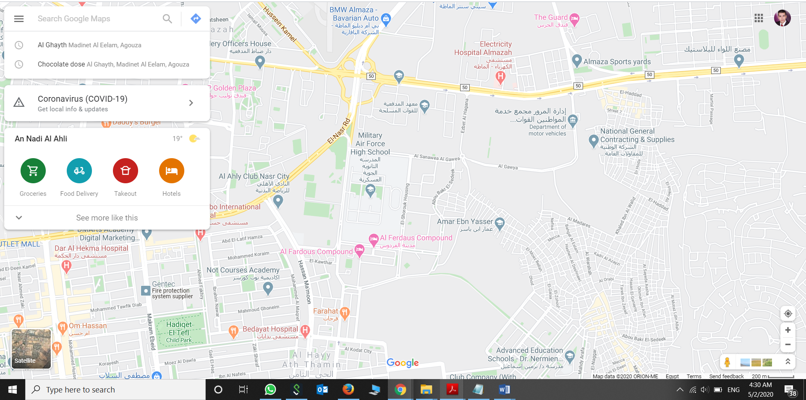

Site 2: <https://www.whitepages.com/reverse-phone>

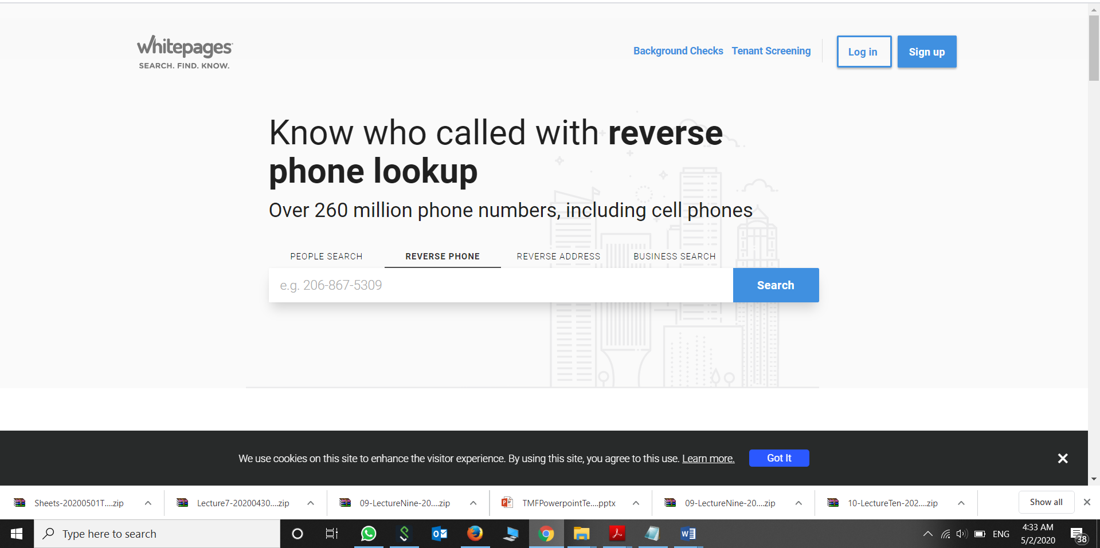

Site3: <https://www.findandtrace.com/trace-std-landline-number>

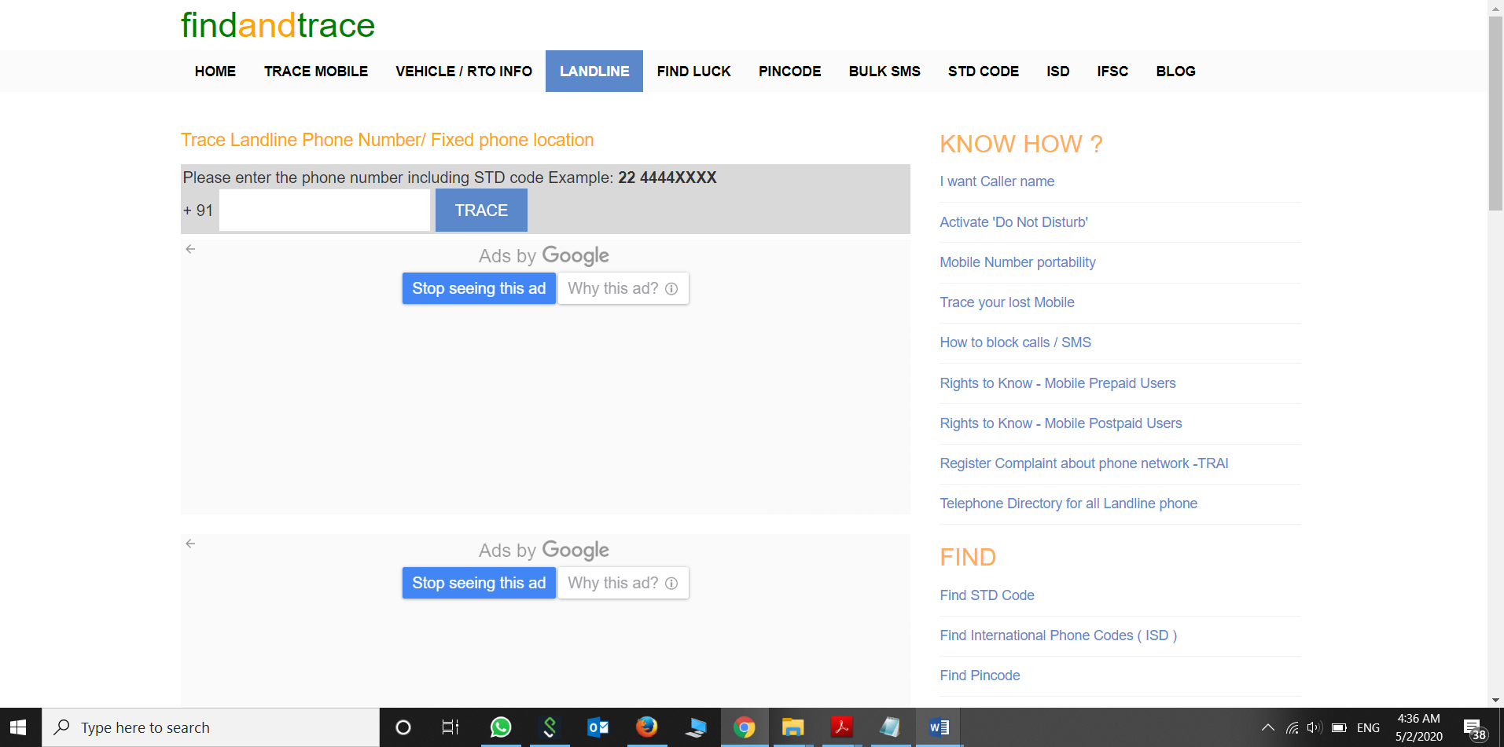

Chapter 2

System Analysis

**2.1. Requirements elicitation**

**2.1.1. Resources**

1. Telecom Egypt
2. Google Map
   * 1. **Tools or Method** 
        + Sampling of existing documentation, forms and databases.
        + Research and site visits.
        + Observation of the work environment.
        + Interviews.
        + Prototyping

# **2.2. System Requirement Specification**

## **2.2.1. Functional Requirements**

## **2.2.1.1. Manage Countries [MS]**

|  |  |
| --- | --- |
| **Requirement ID** | **Requirement Description** |
| **1-** **MCo-1** | The system must allow the admin to “add” new country. |
| **2- MCo-2** | The system must allow the admin to “update” the selected country data. |
| **3- MCo-3** | The system must allow the admin to “delete” the selected country. |

**Table 2.2 Functional Requirement of Manage Countries**

### **2.2.1.2. Manage Cities [MC]**

|  |  |
| --- | --- |
| **Requirement ID** | **Requirement Description** |
| **1- MCi-1** | The system must allow the admin to “add” new city. |
| **2- MCi-2** | The system must allow the admin to “update” the selected city data. |
| **3- MCi-3** | The system must allow the admin to “delete” the selected city. |

**Table 2.2 Functional Requirement of Manage Cities**

### **2.2.1.3. Manage Areas [MA]**

|  |  |
| --- | --- |
| **Requirement ID** | **Requirement Description** |
| **1- MA-1** | The system must allow the admin to “add” new area. |
| **2- MA-2** | The system must allow the admin to “update” the selected area. |
| **3- MA-3** | The system must allow the admin to “delete” the selected area. |

**Table 2.3 Functional Requirement of Manage Areas**

### **2.2.1.4. Manage Cabins [MC]**

|  |  |
| --- | --- |
| **Requirement ID** | **Requirement Description** |
| **1- MCa-1** | The system must allow the admin to “add” new cabin. |
| **2- MCa-2** | The system must allow the admin to “update” the selected cabin data. |
| **3- MCa-3** | The system must allow the admin to “delete” the selected cabin. |

**Table 2.4 Functional Requirement of Manage Cabins**

### **2.2.1.5. Manage Boxes [MB]**

|  |  |
| --- | --- |
| **Requirement ID** | **Requirement Description** |
| **1- MB-1** | The system must allow the admin to “add” new box. |
| **2- MB-2** | The system must allow the admin to “update” the selected box data. |
| **3- MB-3** | The system must allow the admin to “delete” the selected box data. |

**Table 2.5 Functional Requirement of Manage Boxes**

### **2.2.1.6. Manage User Services [MM]**

|  |  |
| --- | --- |
| **Requirement ID** | **Requirement Description** |
| **1- MUS-1** | The system must allow the user/ visitor to search for address without register. |
| **2- MUS-2** | The system must allow the user to log-in and allow visitor to create account to enjoy more services. |
| **3- MUS-3** | The system allow the user to search for by features. |
| **4- MUS-4** | The system allow the user manage his/her profile. |
| **5- MUS-5** | The system allow the user to subscribe in special services. |

**Table 2.6 Functional Requirement of Manage User Services**

## **2.2.2 Non-Functional Requirements**

Non-functional requirements are requirements that specify criteria of the developed system. This can be used to judge the operation of the system, rather than specific behaviors. This is contrasted with functional requirements that define the specific behaviors or function of the system.

### **2.2.2.1. Performance Requirements**

|  |  |
| --- | --- |
| **Requirement ID** | **Requirement Description** |
| **1- PR 1** | The system must hosted on a Linux server in order to achieve high performance. |
| **2- PR 2** | The system should be compatible with all modern browsers. |
| **3- PR 3** | The system should uses Java to achieve great performance. |

**Table 2.7 Performance Requirement of the system**

### **2.2.2.2. Safety and Security Requirements**

System cannot affect, harm, damage to user. It also cannot damage user’s computer while accessing the system over a network

|  |  |
| --- | --- |
| **Requirement ID** | **Requirement Description** |
| **1- SSR** | Among the safety rules is that the site allows the user to browse and benefit from public services, but prepaid services can only be used after subscription. |
| **2- SSR** | Force the user to exit the application if he leaves it for an hour without interacting to keep his account secure |

### **2.2.2.3. Other Software Quality Attributes**

**2.2.2.3.1** **Usability**

We will use Angular and bootstrap for ease of use and to improve the best UI / UX as the user has a simple and fast browsing interface and easily accesses what he wants without any complications and the system flow take into account the user's needs and achieve the desired benefit from it.

**2.2.2.3.2** **Availability and Reliability**

The system will be up normally, but it will be down every three weeks for an hour for maintenance and deployment new updates.

The system will be available all day, except from 7 pm to 9 pm will work at 80 percent.

**2.2.2.3.3 Scalability**

This system currently supports Egypt, but since we will use Angular, Spring and Java to write code that can easily expand the system, expand functions and requirements, and expand features as we want , we will be able to cover Arab countries and Africa .

**TeleGo Actors Description**

|  |  |  |
| --- | --- | --- |
| Actor | Actors Goal | Use Case Name |
| **Admin** | Manage all system | Management – (UC-1) |
| **User(Visitor/Logged-in)** | Login the system/register for first time | Login/Registration –(UC-2) |
| **User(Visitor/Logged-in)** | Search for specific address using landline phone | Search by Phone -(UC-3) |
| **Logged-in User** | Search for people who share the same interests | Search by features –(UC-4) |
| **Logged-in User** | Can change his profile (change photo , features , notes) | Edit Profile –(UC-5) |
| **Logged-in User** | Subscribe in prepaid service | Subscribe –(UC-6) |
| **Logged-in User** | Receive order from specific/ pre-defined place | Drop-point deli vary –(UC-7) |

**Table 2.8 Actor description**

**USE CASE description**

|  |  |
| --- | --- |
| Use case 1 –(UC-1) | |
| Related Requirements | MCo-1 , MCo-2 , MCo-3 , MCi-1 , MCi-2 , MCi-3 ,MA-1 , MA-2 , MA-3 , MCa-1 , MCa-2 , MCa-3 , MB-1 , MB-2 , MB-3 |
| Intiating Actor | Admin |
| Actors Goal | Manage all system |
| Precondition | Has the authentication to manage the system (special username & password) |
| Postcondition | System data change continuously (insert , update , delete) |
| Flow of events for Main Success Senario : | |
| 1. Admin enter username and password | |
| 1. The system checks the information validity. | |
| 1. If theses username and password are valid and special for this person (not normal user), the system will give him permission to manage the system. | |
| Flow Of events For Extensions : | |
| Username and password are not valid.   1. System will not give him permission | |
| 1. System show an error message, ask the user to enter the correct username and password again. | |
| 1. After 3 attempts, this person will not be allowed to enter any new information. | |

**Table 2.9 Use_case 1 description**

**User acceptance test case**

|  |  |
| --- | --- |
| **Test Case Identifier** | TC-1 |
| **Use Case tested** | UC1 |
| **Pass/Fail criteria** | The test passes if the admin manage (update/delete) data that already exist Or insert new data. |
| **Input data** |  |
| **Test Procedure** | Expected Result |
| **Step.1**  (Update/delete) data and Insert data that already exists. | System will show message “The data cannot be duplicated”. |
| **Step.2**  (Update/delete) data and Insert new data. | The system will accept this data and save it to the database. |

**Table 2.10 Use case 1 test cases**

**Login In**

**USE CASE description**

|  |  |
| --- | --- |
| **Use case 2 –(UC-2)** | |
| **Related Requirements** | MUS-2 |
| **Initiating Actor** | Logged-in user |
| **Actors Goal** | Login the system. |
| **Precondition** | The system database contains all data about usernames & passwords of users. |
| **Postcondition** | The system validate username and password. |
| **Flow of events for Main Success Scenario :** | |
| 1. The user enter his/her username and password. | |
| 1. The system check the information validity. | |
| 1. If username and password are valid, the system give permission to enter the system. | |
| Flow Of events For Extensions : | |
| 1. The username, password, or both are not valid. | |
| 1. The system ask the user to enter the username, password, or both again. | |

**Table 2.11 Use case 2 description**

**User acceptance test case**

**Test case 1**

|  |  |
| --- | --- |
| Test Case Identifier | TC-2 |
| Use Case tested | UC2 |
| Pass/Fail criteria | The test passes if the user enters a valid username and valid password. |
| Input data | Username and password |
| Test Procedure | Expected Result |
| Step.1  Insert valid username with incorrect password. | System will show the message “The password is not correct” and ask the user to enter a valid password. |
| Step.2  Insert a valid username with correct password. | System will accept username and password and show user profile. |

**Table 2.12 Use case 2 test cases**

**Test case 2**

|  |  |
| --- | --- |
| **Test Case Identifier** | TC-2 |
| **Use Case tested** | UC2 |
| **Pass/Fail criteria** | The test passes if the user enters a valid username and valid password. |
| **Input data** |  |
| **Test Procedure** | Expected Result |
| **Step.1**  **Insert invalid username with correct password.** | System will show the message “The username is not correct” and ask the user to enter username again. |
| **Step.2**  **Insert a valid username with correct password.** | System will accept username and password and show user profile. |

**Table 2.13 Use case 2 test case 2**

**Test case 3**

|  |  |
| --- | --- |
| **Test Case Identifier** | TC-2 |
| **Use Case tested** | UC2 |
| **Pass/Fail criteria** | The test passes if the user enters a valid username and valid password with less than 3 times. |
| **Input data** |  |
| **Test Procedure** | Expected Result |
| **Step.1**  **Insert invalid username with correct password or vice versa for 3 times.** | System will show the message “Your attempts are over, please try after one hour”. |

**Table 2.14 Use case 2 test case 3**

**Registration**

**USE CASE description**

|  |  |
| --- | --- |
| **Use case 2 –(UC-2)** | |
| **Related Requirements** | MUS-2 |
| **Initiating Actor** | Visitor |
| **Actors Goal** | Visitor try to register to enjoy more site services. |
| **Precondition** |  |
| **Postcondition** | The system will save unique username and password for new user to the database. |
| Flow of events for Main Success Scenario : | |
| 1. The visitor fill the registration form correctly. | |
| 1. The system checks that all required fields are filled. | |
| 1. The system sends this form to the server to ensure that all informations are unique and not similar to other users that already exists in the system database. | |
| Flow Of events For Extensions : | |
| 1. The visitor does not fill all required fields.   The system ask the visitor to fill all of them. | |
| 1. The visitor fill the form with data that already exists (used) by another user.   The system will ask the him/her to try with another new data | |

**Table 2.15 Use case 2 description (2/ registration)**

**User acceptance test case**

**Test case 1**

|  |  |
| --- | --- |
| **Test Case Identifier** | TC-2 |
| **Use Case tested** | UC2 |
| **Pass/Fail criteria** | The test passes if the visitor fill all required fields with unique (not repeated) data. |
| **Input data** | Registration form (username, password, email…) |
| **Test Procedure** | Expected Result |
| **Step.1**  **Fill all required fields with some repeated data.** | System will show the message “This data (username or password or … has been taken)” and ask the visitor to try again. |
| **Step.2**  **Fill all required fields with unique data.** | System will accept the form and show the profile of the new user. |

**Table 2.16 Use case 2 test case 1**

**Test case 2**

|  |  |
| --- | --- |
| **Test Case Identifier** | TC-2 |
| **Use Case tested** | UC2 |
| **Pass/Fail criteria** | The test passes if the visitor fill all required fields with unique (not repeated) data. |
| **Input data** | Registration form (username, password, email…) |
| **Test Procedure** | Expected Result |
| **Step.1**  **Fill some required fields with unique data.** | System will show the message “Some required fields must be filled)”. |

**Table 2.17 Use case 2 test case 2**

**Search by Phone**

**USE CASE description**

|  |  |
| --- | --- |
| **Use case 3 –(UC-3)** | |
| **Related Requirements** | MUS-1 |
| **Initiating Actor** | Visitor / User |
| **Actors Goal** | Search for specific address using landline phone. |
| **Precondition** | The system database contains all the data about registered landline phones. |
| **Postcondition** | The system will show address in details of the entered landline phone. |
| Flow of events for Main Success Senario : | |
| 1. The person enter landline phone. | |
| 1. The system checks the phone validity (Country & City Code). | |
| 1. If the phone is valid, the system send it to the server to get details of address. | |
| Flow Of events For Extensions : | |
| 1. The phone is not valid. | |
| 1. The system show an error message “This is invalid landline phone” and ask user to try again. | |

**Table 2.18 Use case 3 description (search by phone)**

**User acceptance test case**

**Test case 1**

|  |  |
| --- | --- |
| **Test Case Identifier** | TC-3 |
| **Use Case tested** | UC3 |
| **Pass/Fail criteria** | The test passes if the person enter a valid country code, valid city code and registered valid landline phone. |
| **Input data** | Landline phone. |
| **Test Procedure** | Expected Result |
| **Step.1**  **Insert valid country code with invalid city code and registered valid landline phone.** | System will show the message “The country code is not valid” and ask the person to try again. |
| **Step.2**  **Insert valid country code with valid city code and registered valid landline phone.** | System will show the address details of this phone. |

**Table 2.19 Use case 3 test case 1**

**Test case 2**

|  |  |
| --- | --- |
| **Test Case Identifier** | TC-3 |
| **Use Case tested** | UC3 |
| **Pass/Fail criteria** | The test passes if the person enter a valid country code, valid city code and registered valid landline phone. |
| **Input data** | Landline phone. |
| **Test Procedure** | Expected Result |
| **Step.1**  **Insert Invalid country code with valid city code and registered valid landline phone.** | System will show the message “The city code is not valid” and ask the person to try again. |
| **Step.2**  **Insert valid country code with valid city code and registered valid landline phone.** | System will show the address details of this phone. |

**Table 2.20 Use case 3 test case 2**

**Test case 3**

|  |  |
| --- | --- |
| **Test Case Identifier** | TC-3 |
| **Use Case tested** | UC3 |
| **Pass/Fail criteria** | The test passes if the person enter a valid country code, valid city code and registered valid landline phone. |
| **Input data** | Landline phone. |
| **Test Procedure** | Expected Result |
| **Step.1**  **Insert valid country code with valid city code and unregistered valid landline phone.** | System will show the message “This Phone is not registered at system database”. |
| **Step.2**  **Insert valid country code with valid city code and registered valid landline phone.** | System will show the address details of this phone. |

**Table 2.21 Use case 3 test case 3**

**Test case 4**

|  |  |
| --- | --- |
| **Test Case Identifier** | TC-3 |
| **Use Case tested** | UC3 |
| **Pass/Fail criteria** | The test passes if the person enter a valid country code, valid city code and registered valid landline phone. |
| **Input data** | Landline phone. |
| **Test Procedure** | Expected Result |
| **Step.1**  **Insert valid country code with valid city code and registered Invalid landline phone.** | System will show the message “The Landline phone is not valid” and ask the person to try again. |
| **Step.2**  **Insert valid country code with valid city code and registered valid landline phone.** | System will show the address details of this phone. |

**Table 2.22 Use case 3 test case 4**

**Search by Features**

**USE CASE description**

|  |  |
| --- | --- |
| **Use case 4 –(UC-4)** | |
| **Related Requirements** | MUS-3 |
| **Initiating Actor** | User |
| **Actors Goal** | Search for people who share the same interests. |
| **Precondition** | The system database contains data about user’s features. |
| **Postcondition** | The system will show people who share the same interests. |
| Flow of events for Main Success Senario : | |
| 1. The user enter a feature. | |
| 1. The system checks if this feature exist before or not. | |
| 1. If the feature exists, the system send it to the server to get people who share the same one. | |
| Flow Of events For Extensions : | |
| 1. The feature is not exist. | |
| 1. The system add this features to the common database list. | |

**Table 2.23 Use case 4 description (search by feature)**

**User acceptance test case**

**Test case 1**

|  |  |
| --- | --- |
| **Test Case Identifier** | TC-4 |
| **Use Case tested** | UC4 |
| **Pass/Fail criteria** | The test passes if the user enter a valid feature. |
| **Input data** | Features. |
| **Test Procedure** | Expected Result |
| **Step.1**  **Insert valid feature.** | System will show the people who share the same interest. |
| **Step.2**  **Insert Invalid feature.** | System will show the message “There is no person interest of this” and add this new feature to the common database list. |

**Table 2.24 Use case 4 test case**

**Edit Profile**

**USE CASE description**

|  |  |
| --- | --- |
| **Use case 5 –(UC-5)** | |
| **Related Requirements** | MUS-4 |
| **Initiating Actor** | User |
| **Actors Goal** | Can change his profile (change photo, features, and notes). |
| **Precondition** | The user login the system. |
| **Postcondition** | The user profile changed. |
| Flow of events for Main Success Scenario : | |
| 1. The user may change password. | |
| 1. The system send the new password to the server to modify the user data to be allowed to be logged in in next time. | |
| **Table 2.25 Use case 5 description (edit profile)** | |

**User acceptance test case**

**Test case 1**

|  |  |
| --- | --- |
| **Test Case Identifier** | TC-5 |
| **Use Case tested** | UC5 |
| **Pass/Fail criteria** | The test passes if the user save his/her changes to the profile. |
| **Input data** | New password/new photo/add features/write notes. |
| **Test Procedure** | Expected Result |
| **Step.1**  **Save changes after editing profile.** | System will send these changes to the server(system database)to be saved. |
| **Step.2**  **The user did not save changes.** | System database remain as it is and any new updates will be lost. |

**Table 2.26 Use case 5 test case**

**Subscribe**

**USE CASE description**

|  |  |
| --- | --- |
| **Use case 6 –(UC-6)** | |
| **Related Requirements** | MUS-5 |
| **Initiating Actor** | User |
| **Actors Goal** | Subscribe in prepaid packages. |
| Flow of events for Main Success Scenario : | |
| 1. The user try to subscribe to any category of packages. | |
| 1. The system send a message “You must paid first to enjoy this service”. | |

**Table 2.27 Use case 6 description (subscribe)**

**User acceptance test case**

**Test case 1**

|  |  |
| --- | --- |
| **Test Case Identifier** | TC-6 |
| **Use Case tested** | UC6 |
| **Pass/Fail criteria** | The test passes if the user choose the service and paid first to enjoy it. |
| **Input data** | The selected service. |
| **Test Procedure** | Expected Result |
| **Step.1**  **Select service and paid for it.** | The system will show the message “You are now subscribed and you can enjoy this service”. |
| **Step.2**  **Select service and not paid for it.** | The system will show the message “You must paid first to enjoy this service”. |

**Table 2.28 Use case 6 test case**

**Drop-point delivary**

**USE CASE description**

|  |  |
| --- | --- |
| **Use case 7 –(UC-7)** | |
| **Related Requirements** | MUS-5 |
| **Initiating Actor** | User |
| **Actors Goal** | The user apply for order and receive it when reaching the nearest drop-point delivery. |
| Flow of events for Main Success Scenario : | |
| 1. The user apply for order. | |
| 1. The system confirm this order, then the shipping company (department) pack and ship it to the nearest drop-point place. | |
| 1. The drop-point employee either call the user to come to receive the order or deliver it. | |

**Table 2.29 Use case 7 description (drop point delivary)**

**User acceptance test case**

**Test case 1**

|  |  |
| --- | --- |
| **Test Case Identifier** | TC-7 |
| **Use Case tested** | UC7 |
| **Pass/Fail criteria** | The test passes if the user apply for order and the system confirm it, and then the shipping department ship it to the drop-point place. |
| **Test Procedure** | Expected Result |
| **Step.1**  **Select service and paid for it.** | The system will show the message “You are now subscribed and you can enjoy this service”. |
| **Step.2**  **Select service and not paid for it.** | The system will show the message “You must paid first to enjoy this service”. |

**Table 2.30 Use case 7 test case**

Chapter 3

System Design

**3.1. Methodologies of the Project**

**Software programs and Technology**

* + 1. Git
    2. Eclipse
    3. CSS 3.
    4. Javascript
    5. Html 5
    6. JSON
    7. Maven
    8. AJAX
    9. Tomcat
    10. Boostrap
    11. Angular
    12. Spring boot
    13. sqldeveloper
    14. UML Visual Paradigm.
    15. XML
    16. Visual studio Code.

**3.2. Use Cases Diagrams**

**3.2.1. High Level Use Case Diagram of TeleGo Management System**

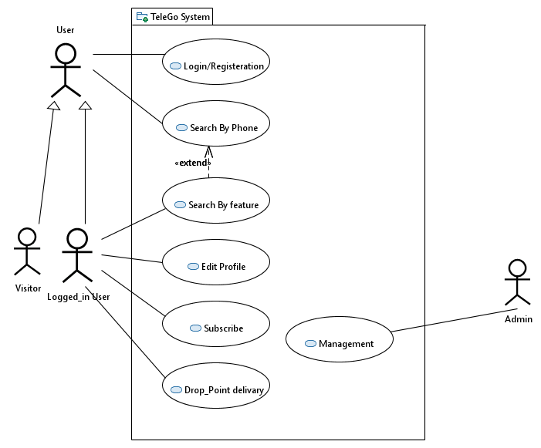  
Figure 3.1 TeleGo system

**3.2.2. Admin Use Case**

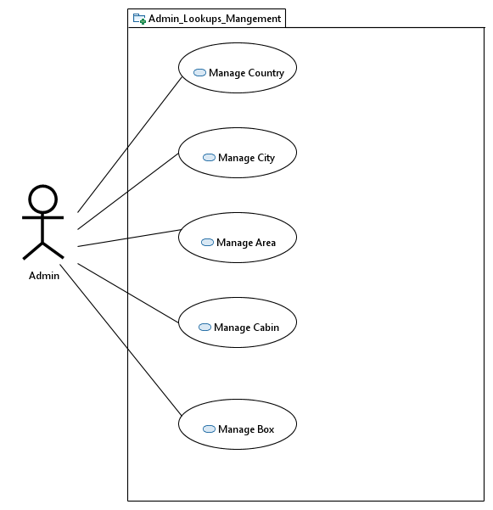

**Figure 3.2 Admin lookups management**

**3.2.3. Profile Use Case**

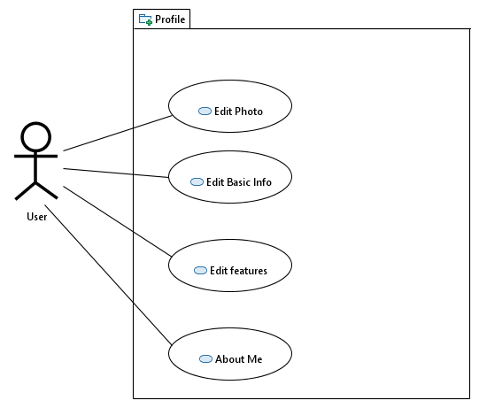

Figure 3.3 profile

**3.2.4. Search & Services Use Case**

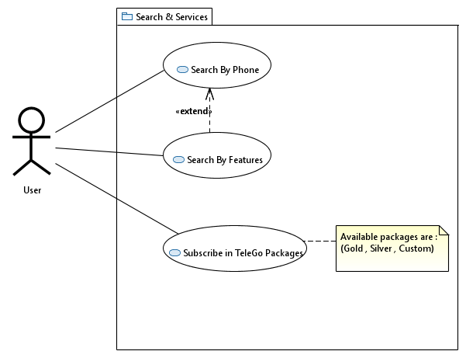

Figure 3.4 search & services

**3.2.5. Drop_Point delivery Use Case**

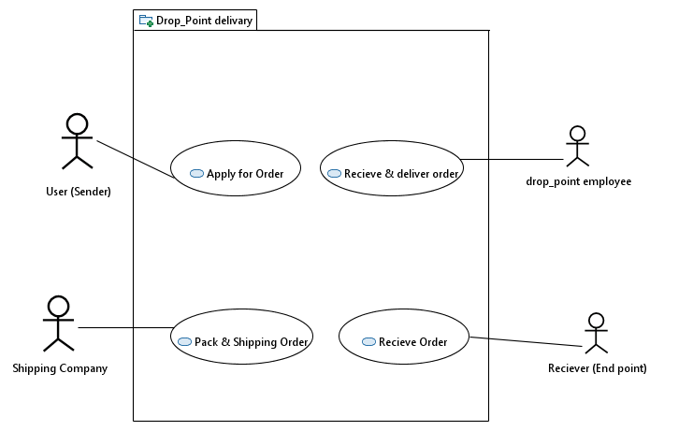

Figure 3.5 drop point delivary

**3.3Activities Diagrams**

**3.3.1. Login or Register**

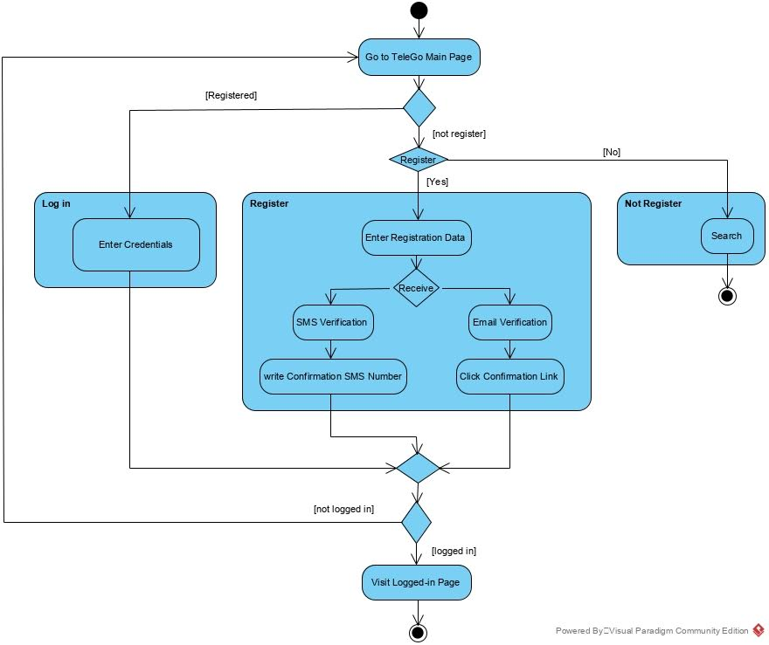

Figure 3.6 login/registeraion

**3.3.2. Activity Diagram_Search**

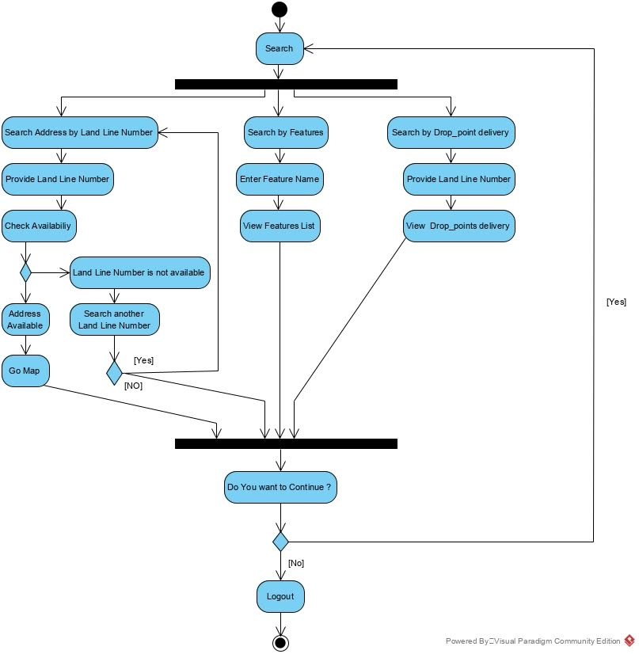

Figure 3.7 Search

* + 1. **Drop_Point delivery**

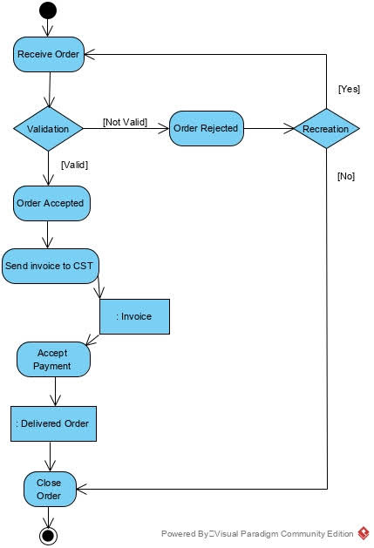

Figure 3.8 drop point delivary

**3.4Class Diagram**

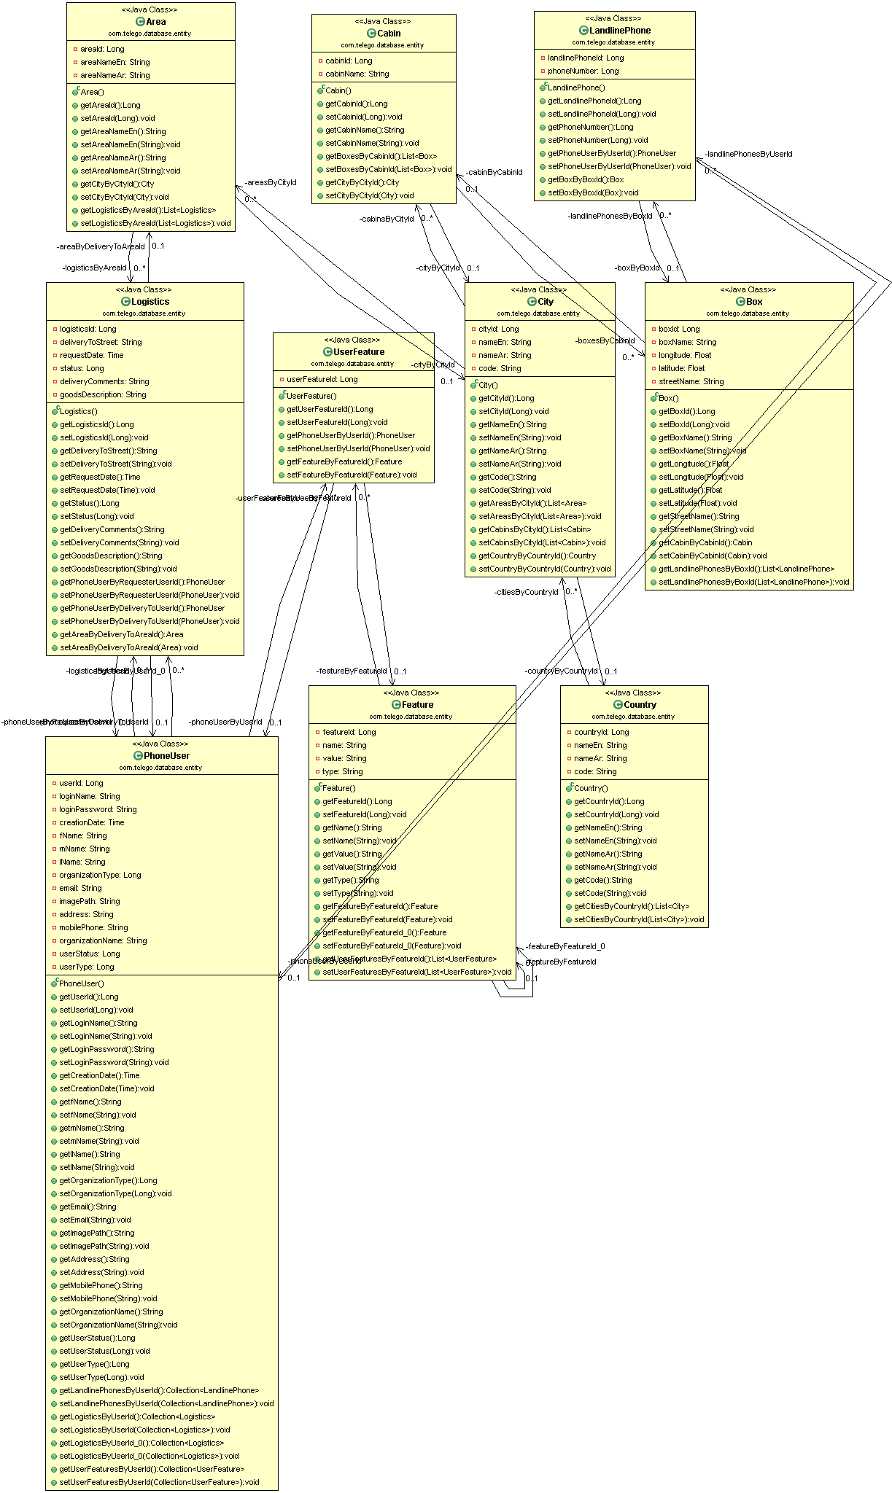

Figure 3.9 class diagram

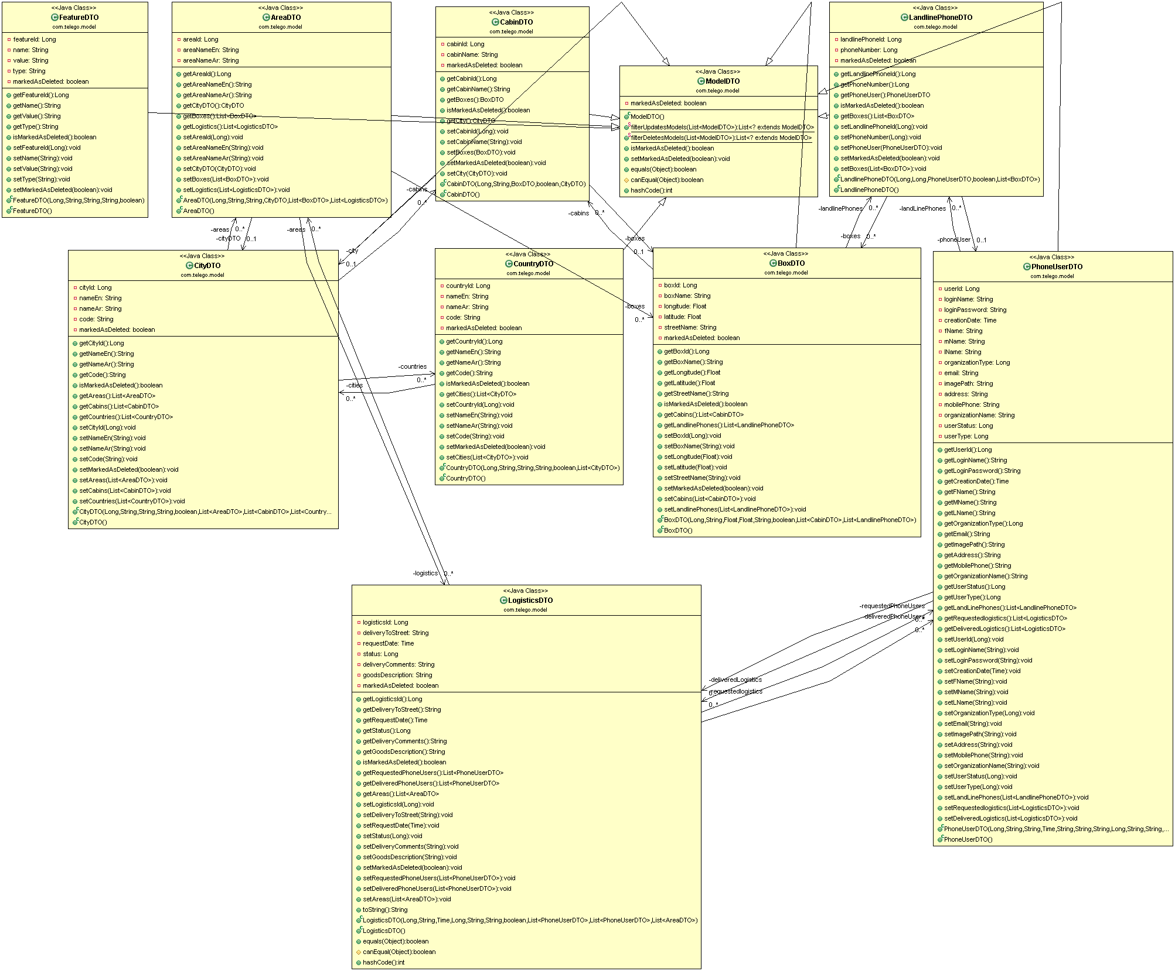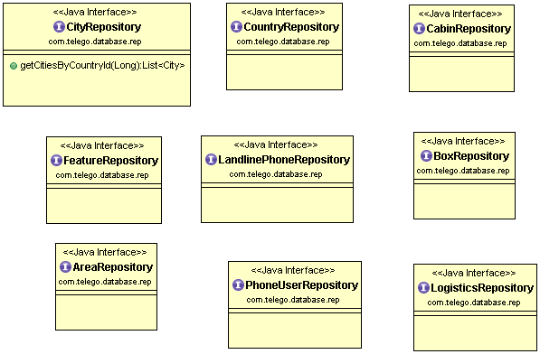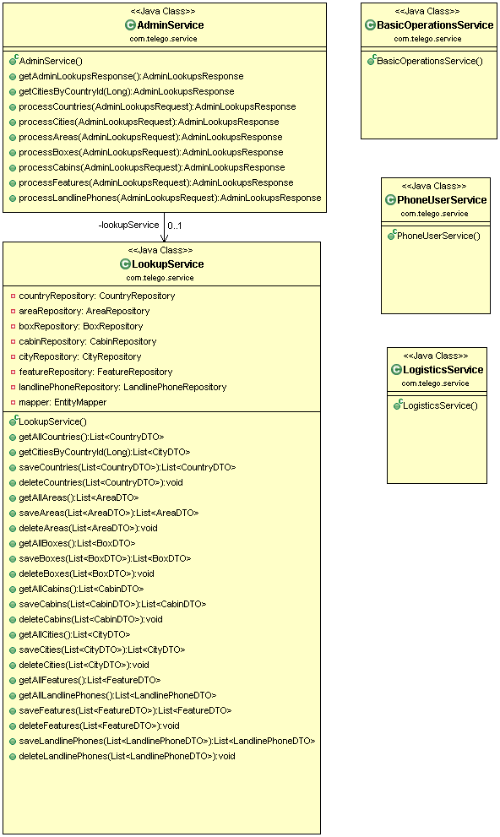

Chapter 4

Implementation

**Search Page**

Any visitor can search for others by phone number or features

**4.1-Search by phone:**

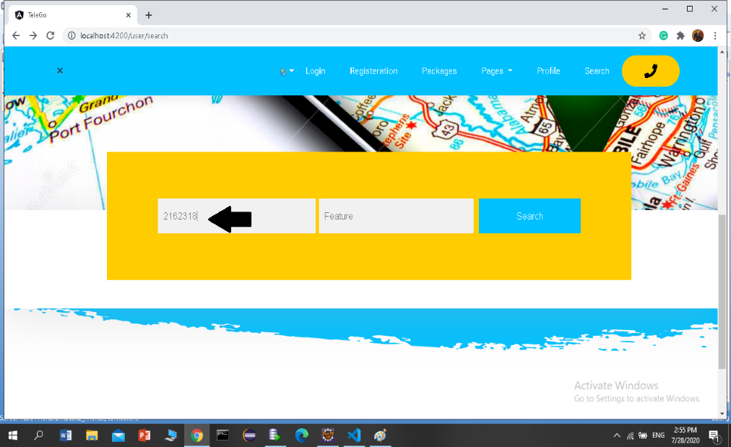

Figure 4.1 Search by Phone

The search result is only one person who owns this phone

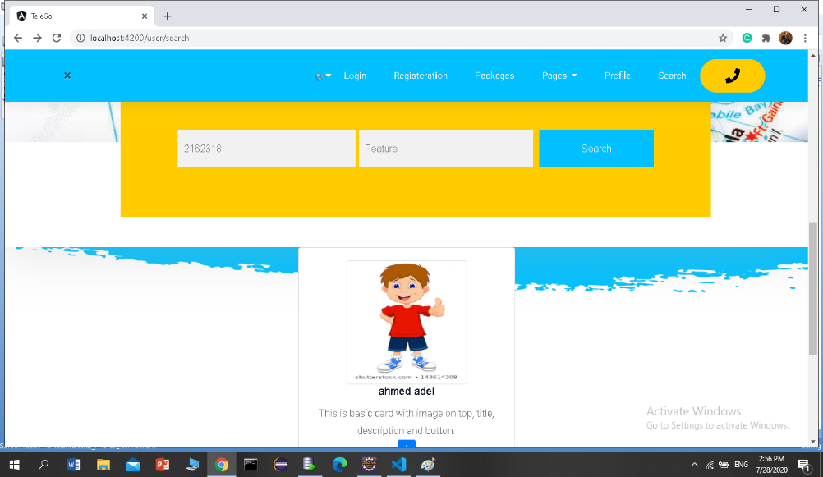

Figure 4.2 Result of Search by Phone

*press to know general information about this user

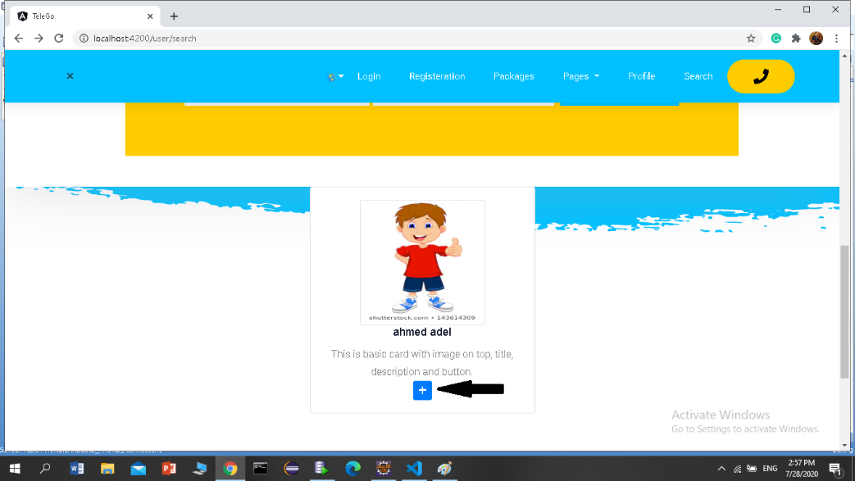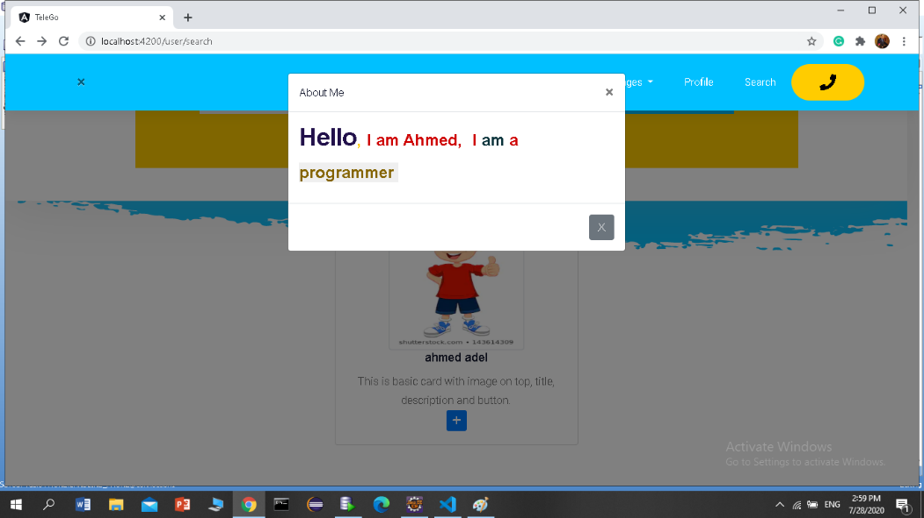

**4.2- Search by Features**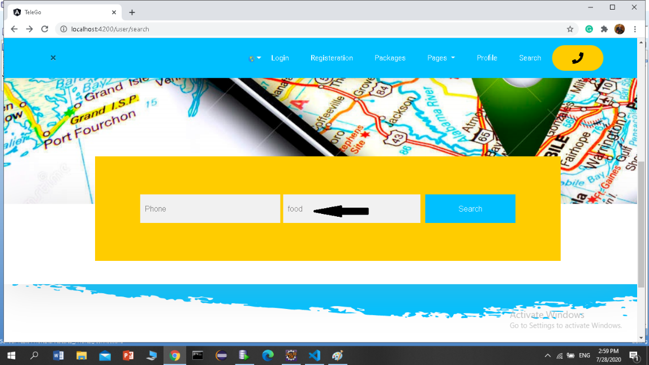

Figure 4.3 Search by Feature

The search result is a person or a group of people who share these characteristics

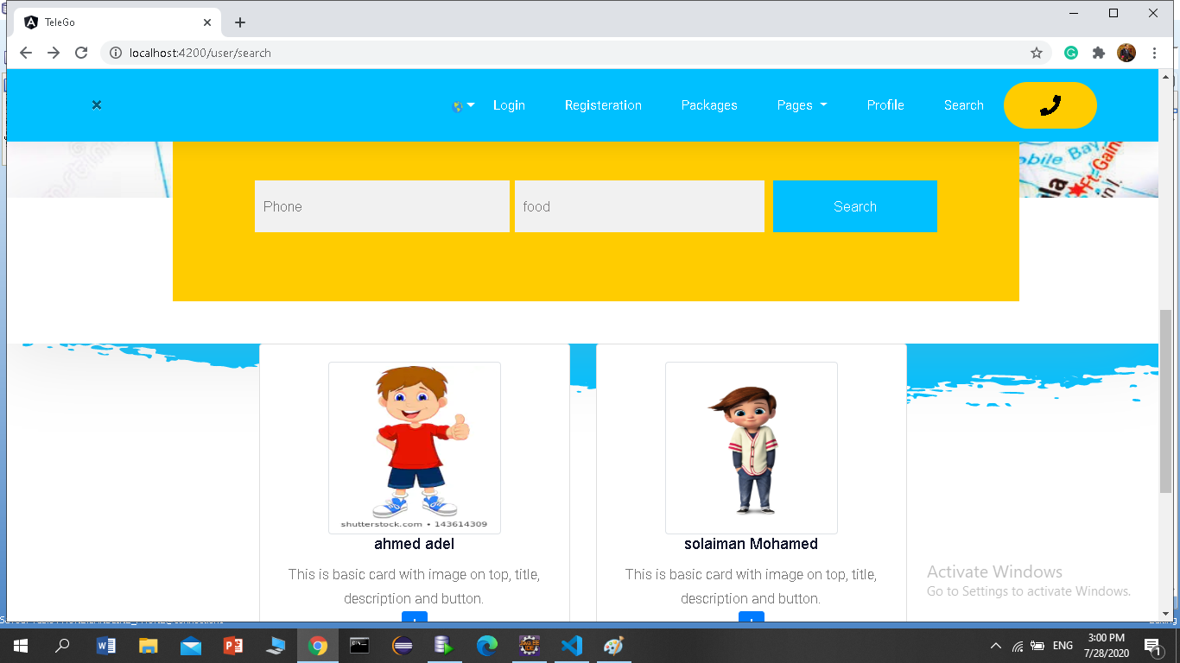

Figure 4.4 Result of search by feature

**4.3.Registration**

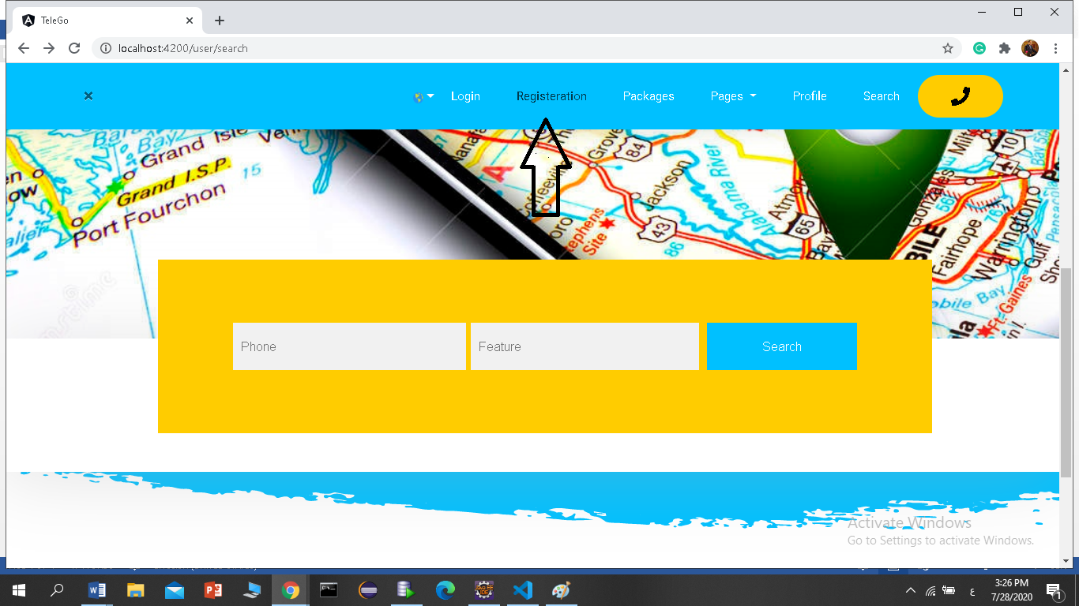

Figure 4.5 Registration

1-User must fill in all required fields

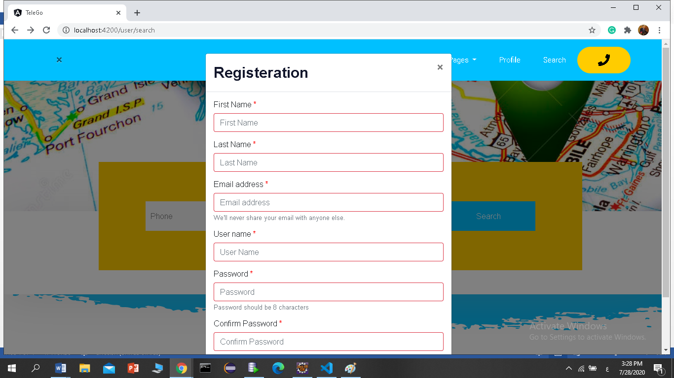

Figure 4.6 Registration form

2-When user enter invalid email, error message will appear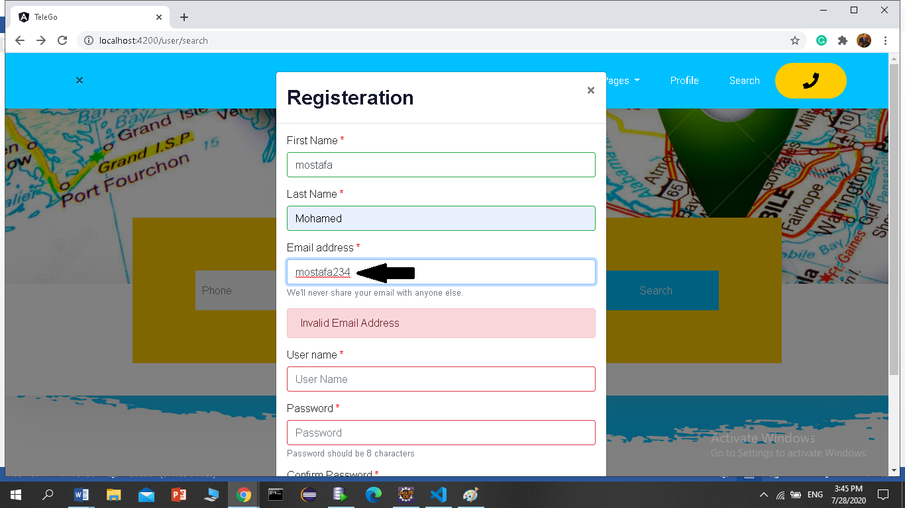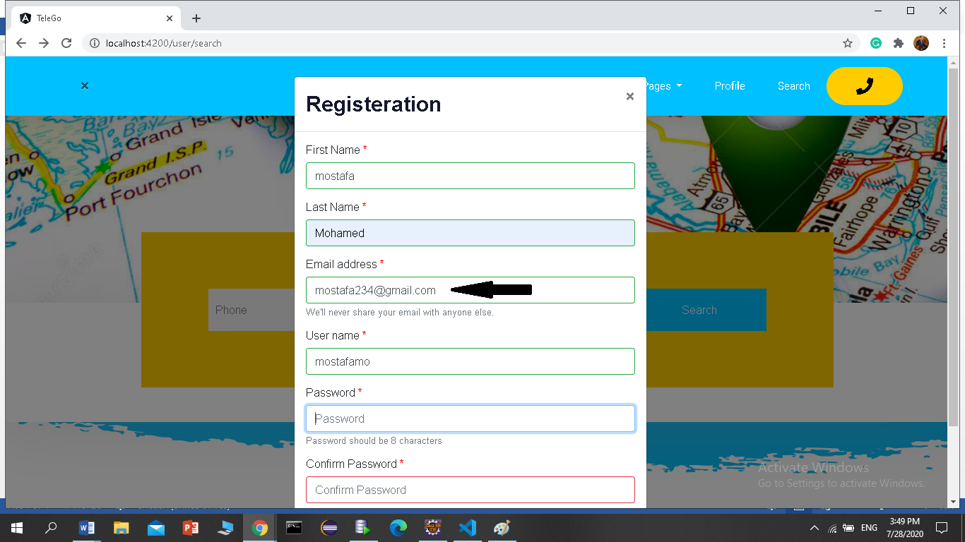

3- When password and confirmation did not match:

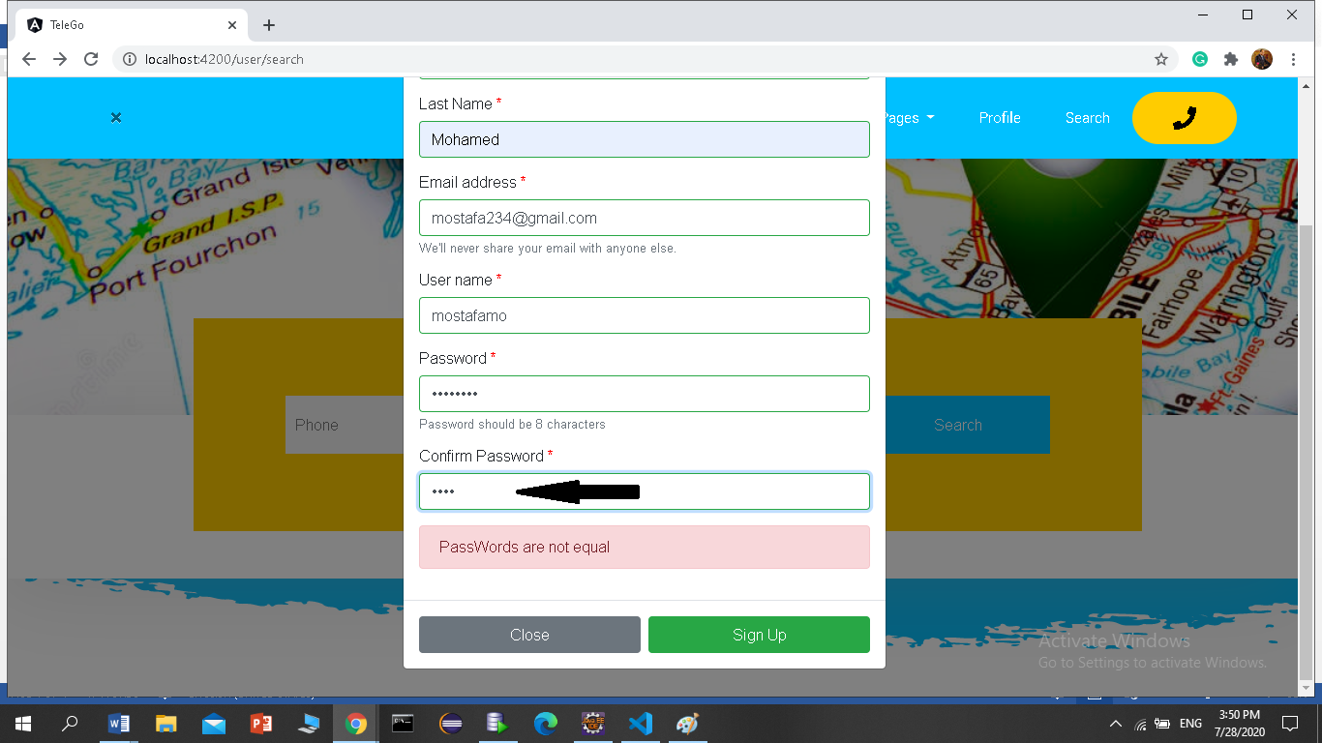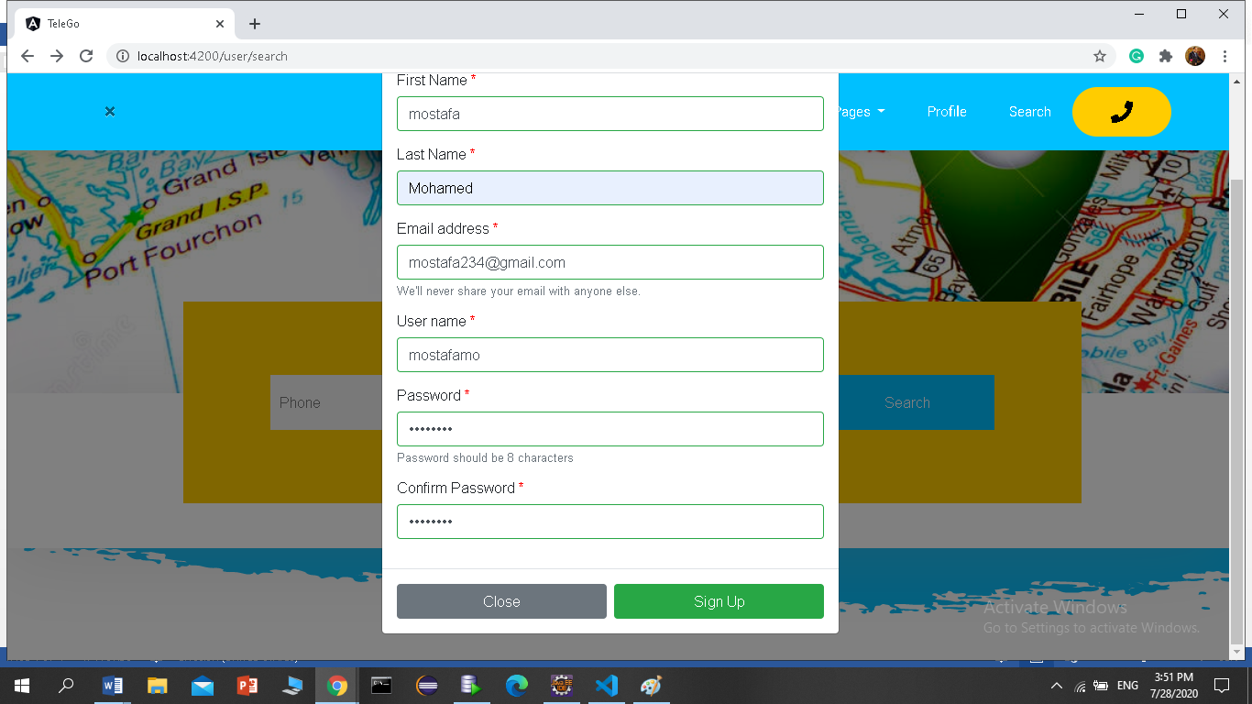

Figure 4.7 properly filled form

4-New user saved at database successfully

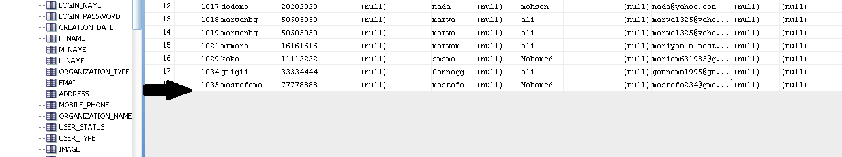

Figure 4.8 New user saved to database

5- Then user turn directly to his profile page to complete it:

**4.4.profile page**

* Add photo

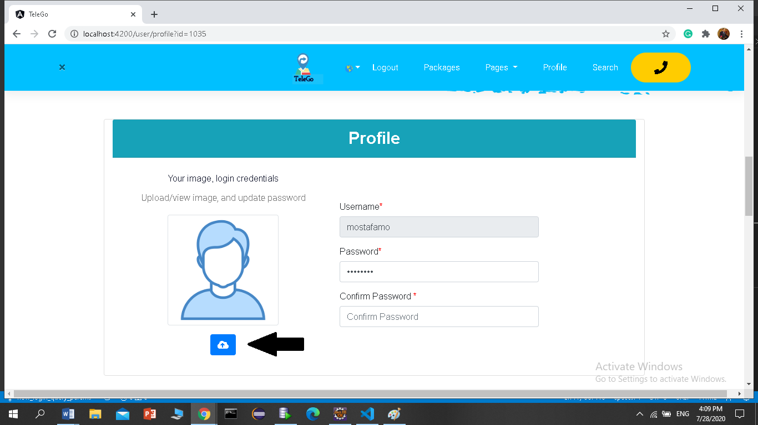

Figure 4.9 Add photo

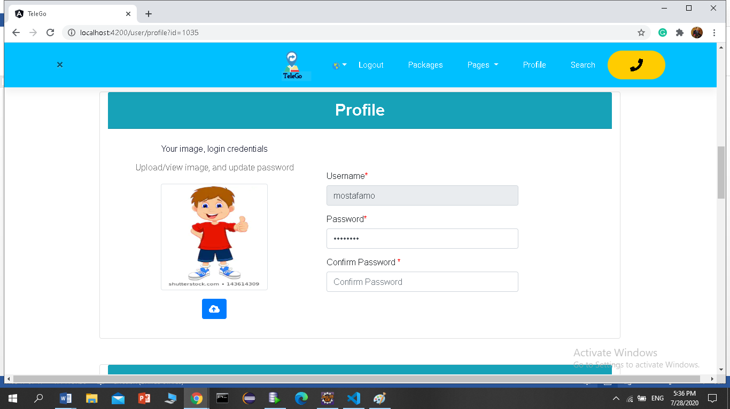

*Add basic info like country, city, phone and address

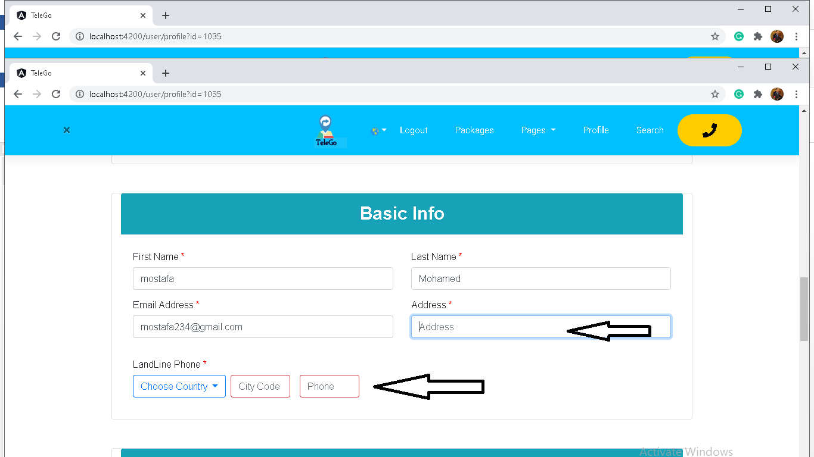

Figure 4.10 Add basic information

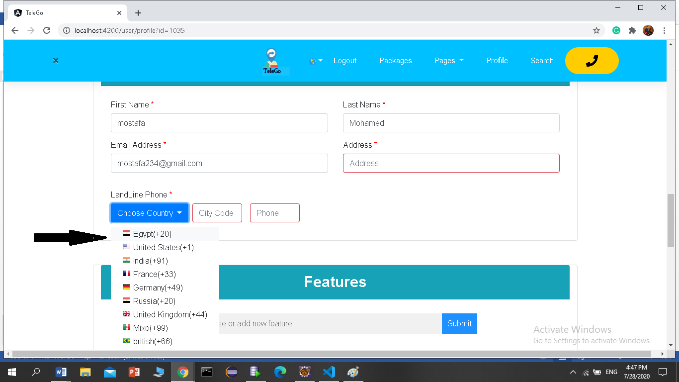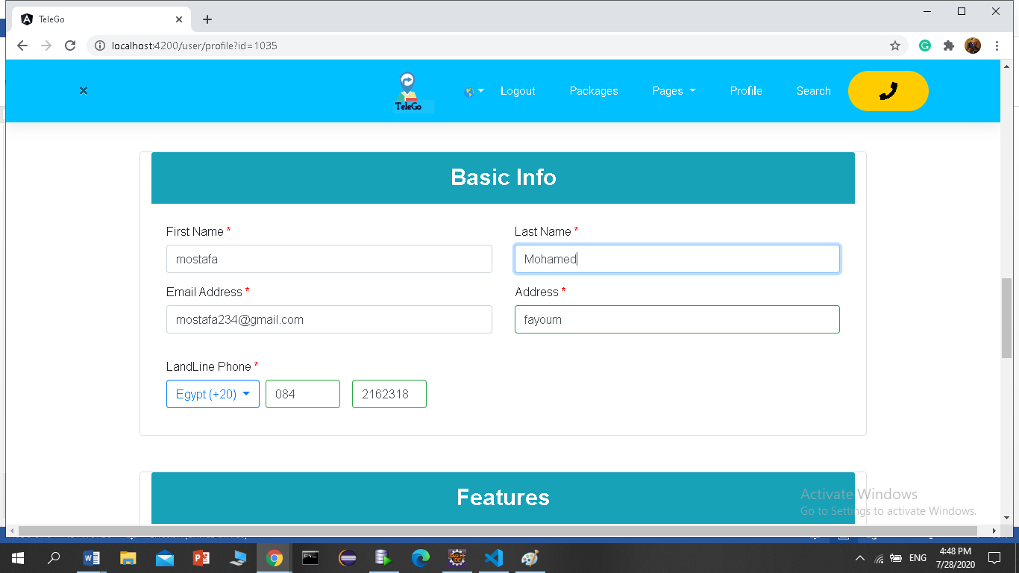

* In feature section , user can search for one of several features kept in the database and appear in gray, then double-click to add it and convert to blue by closing the x button above it

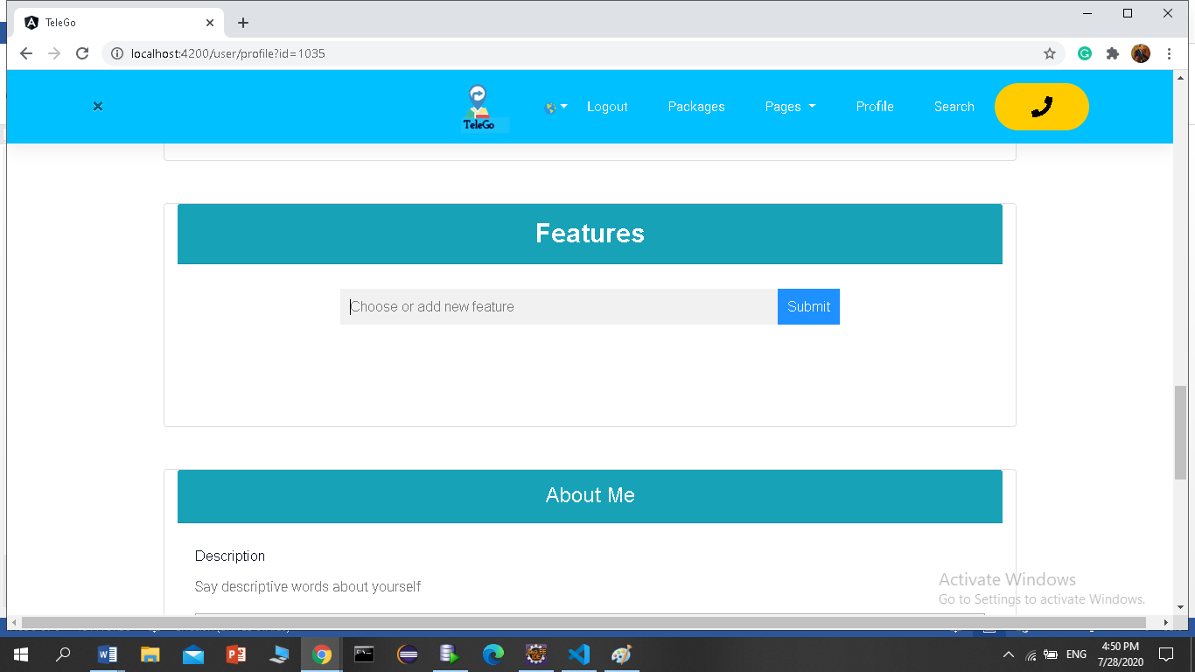

Figure 4.11 Add features

**\*** Once you type the first letter, a list of the properties that start with it appears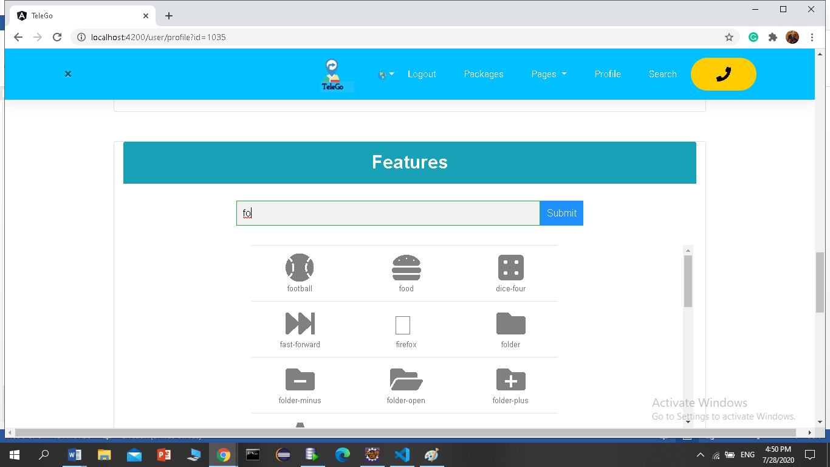

* Unchosen feature

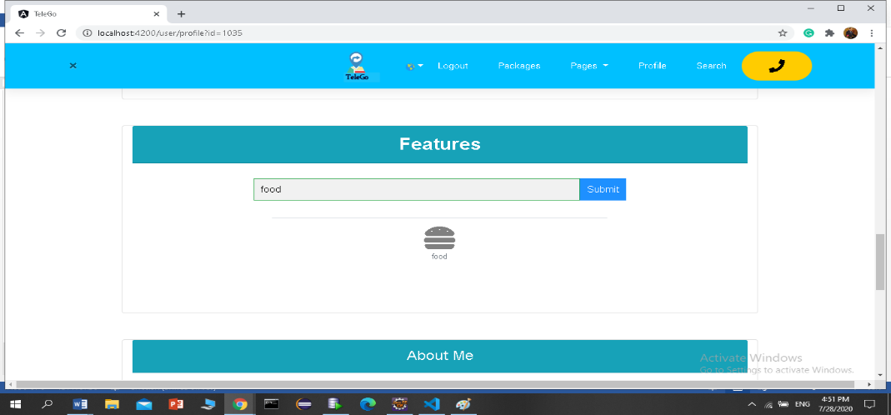

*Chosen features

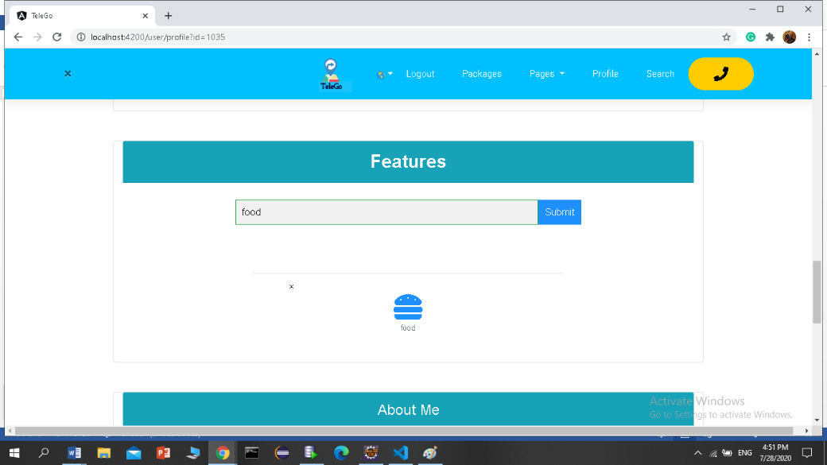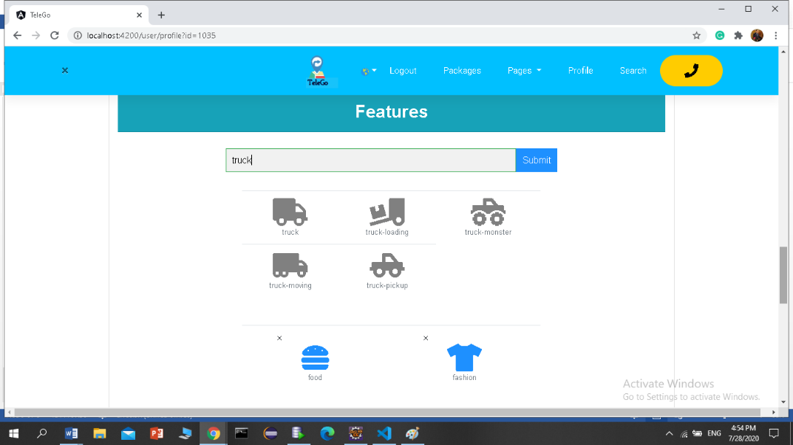

*when user want to delete feature

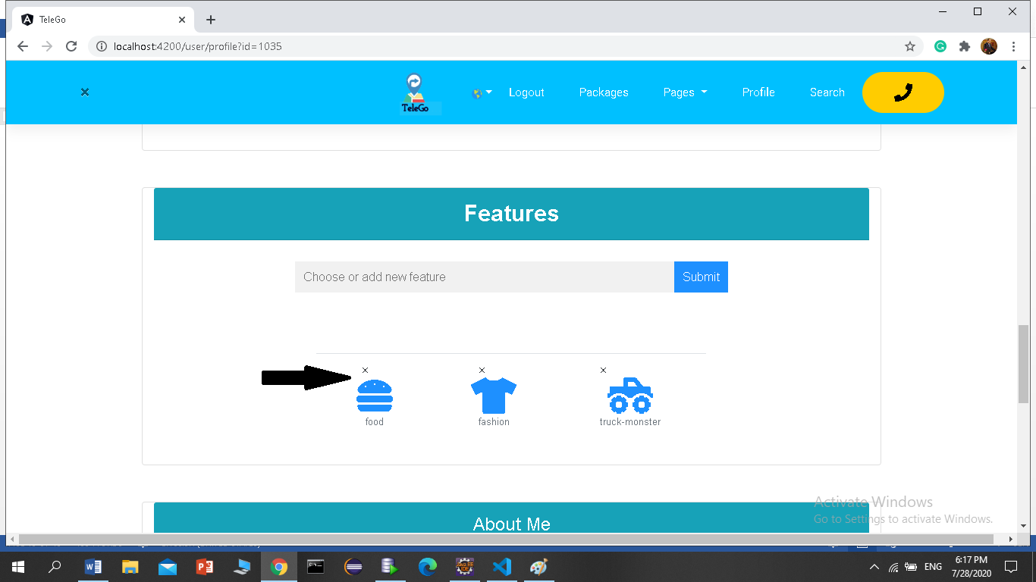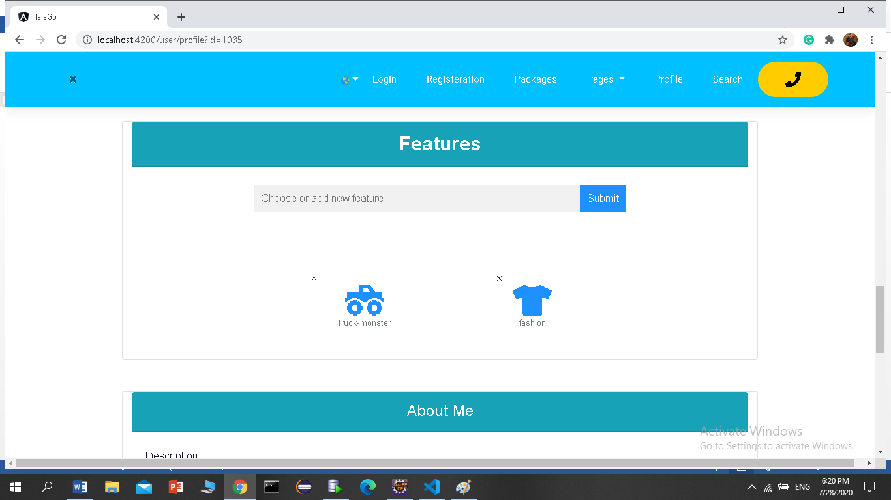

*About me

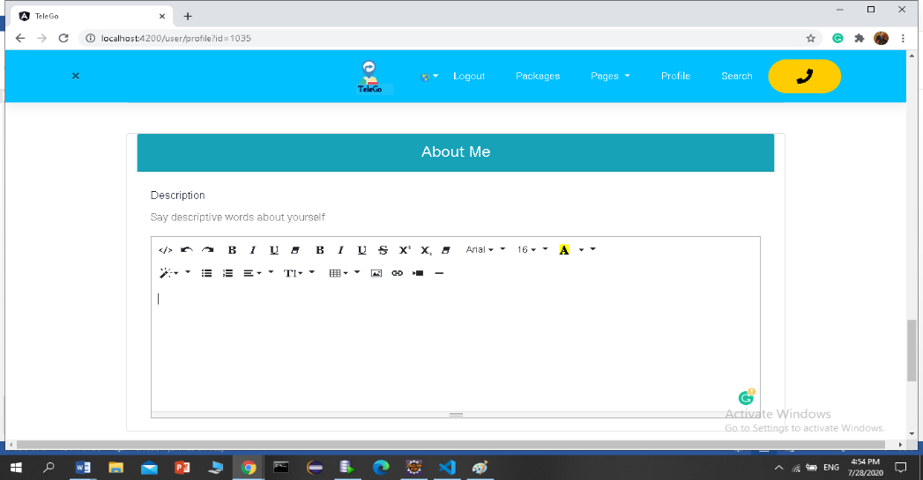

Figure 4.12 Write notes about yourself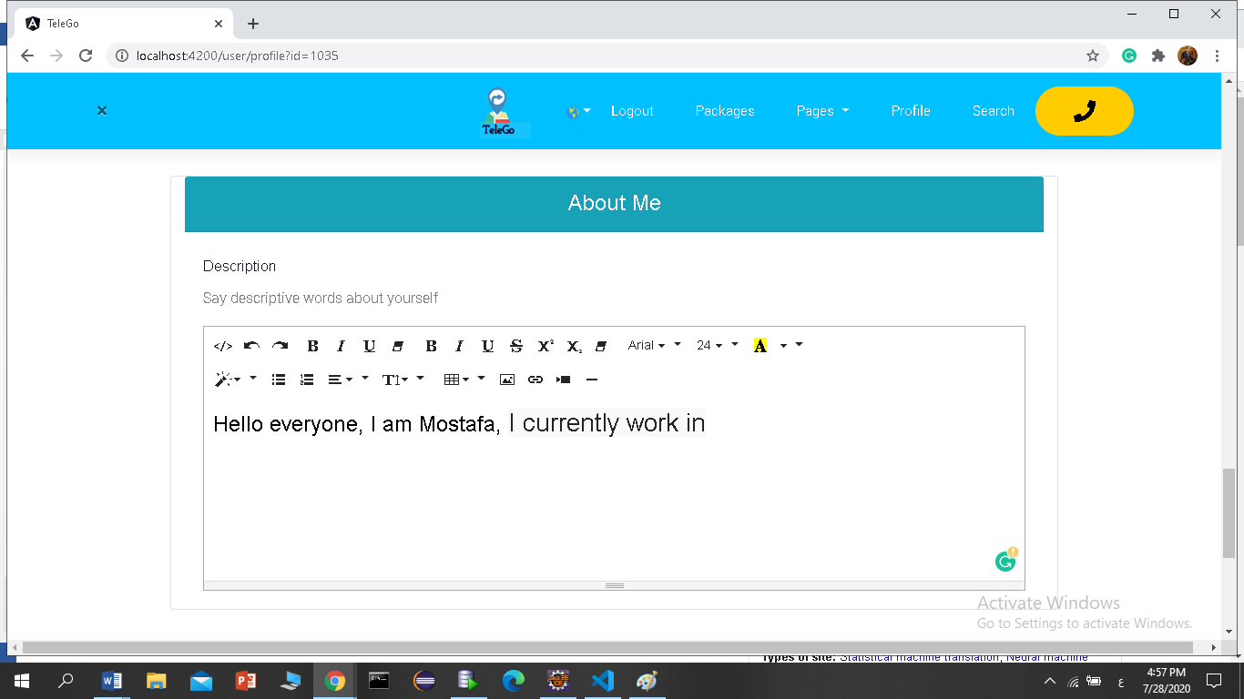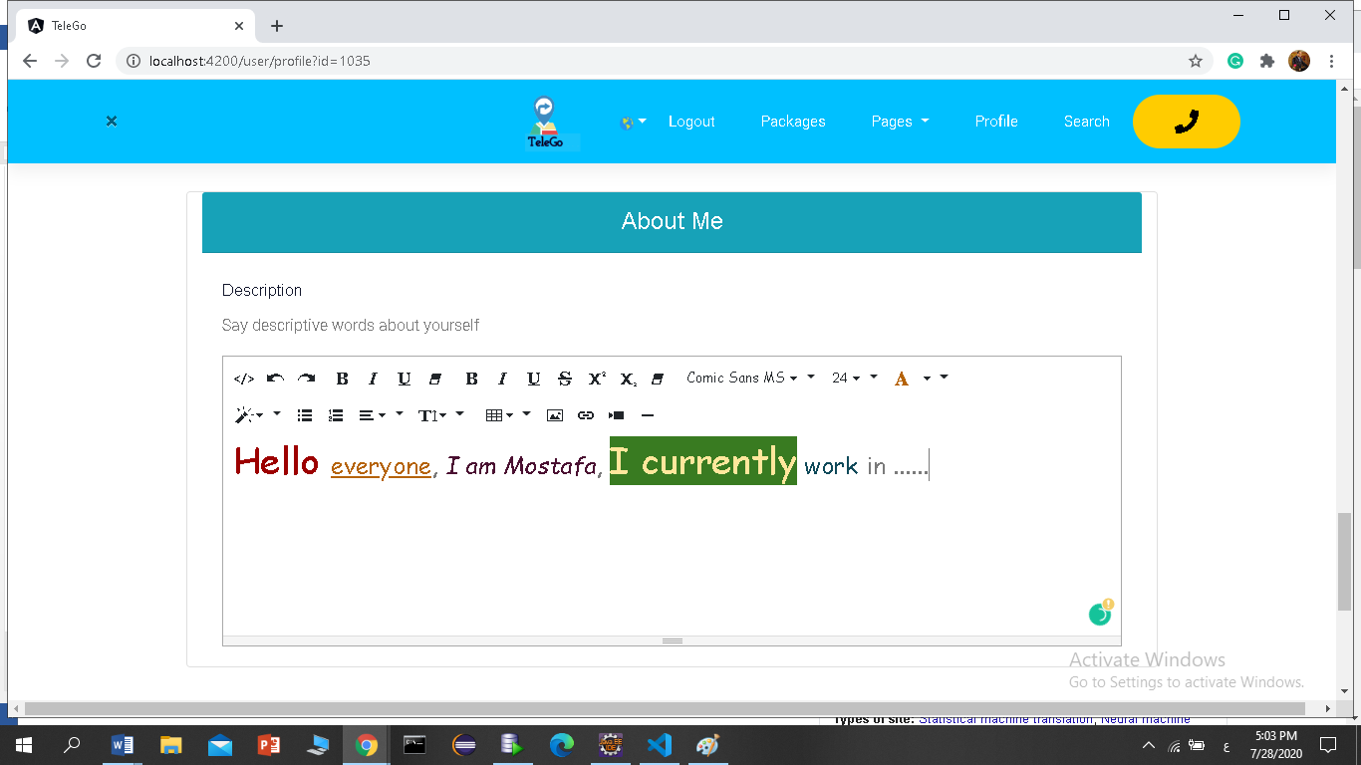

*Save all changes

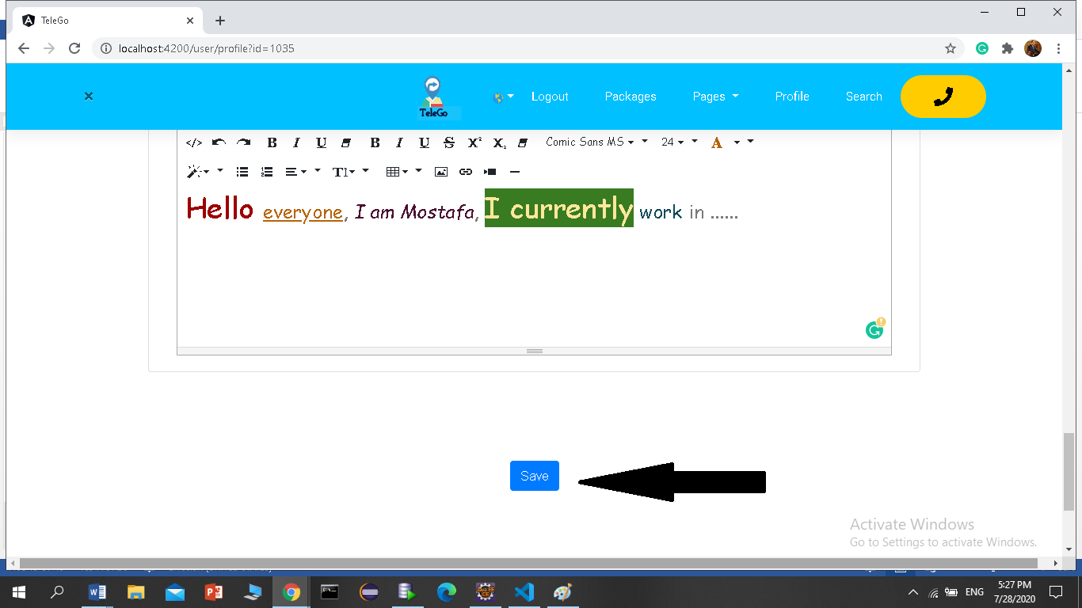

*Profile saved successfully at database

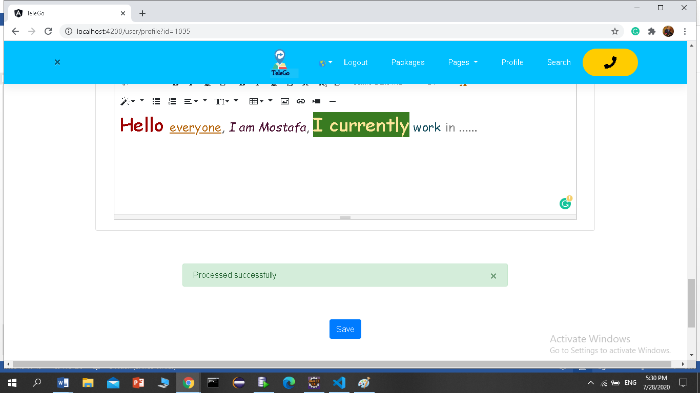

Figure 4.13 save update successfully

* User can logout and login in again to ensure that everything is OK

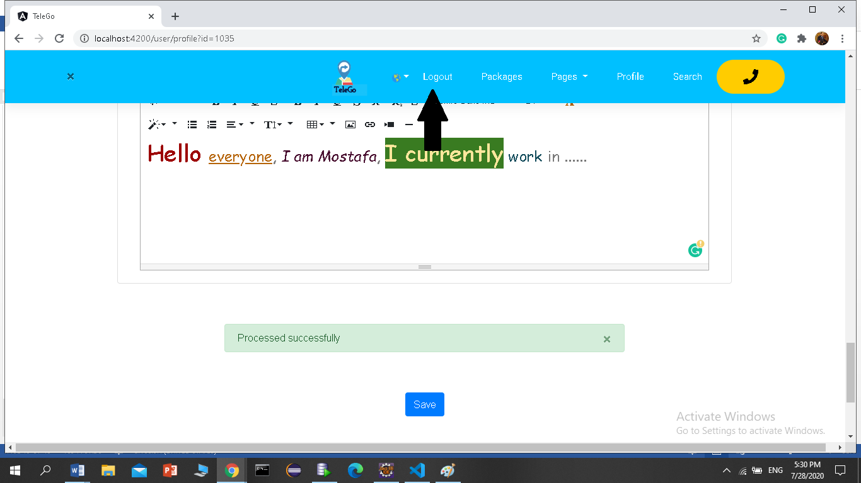

**4.5.Login:**

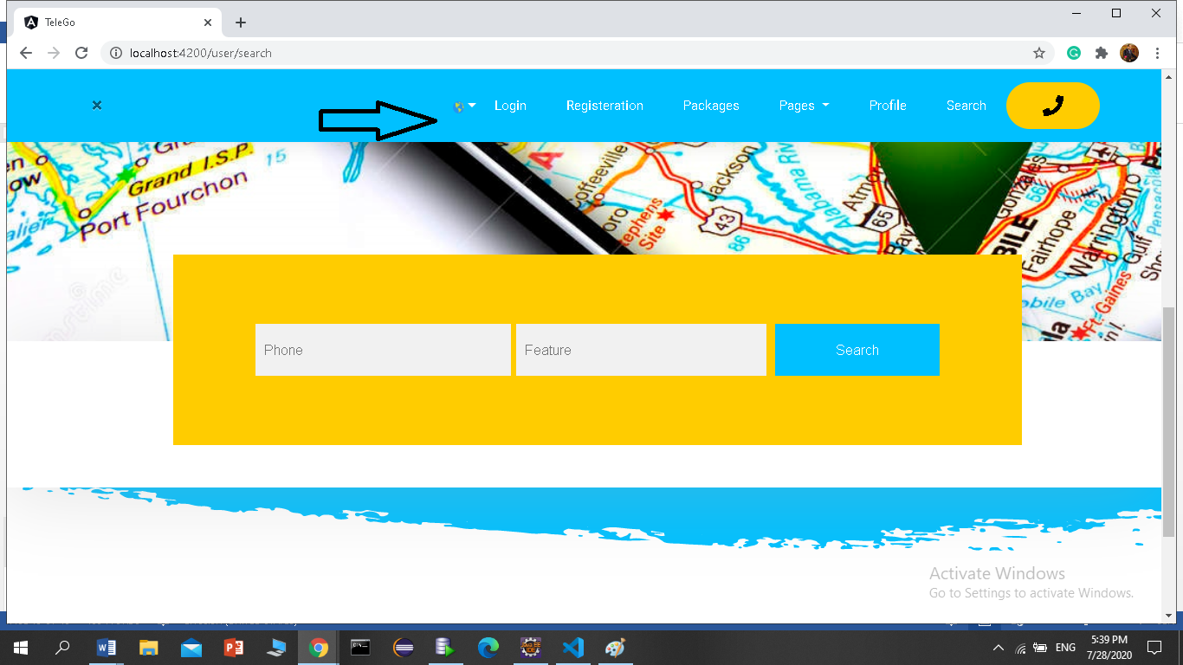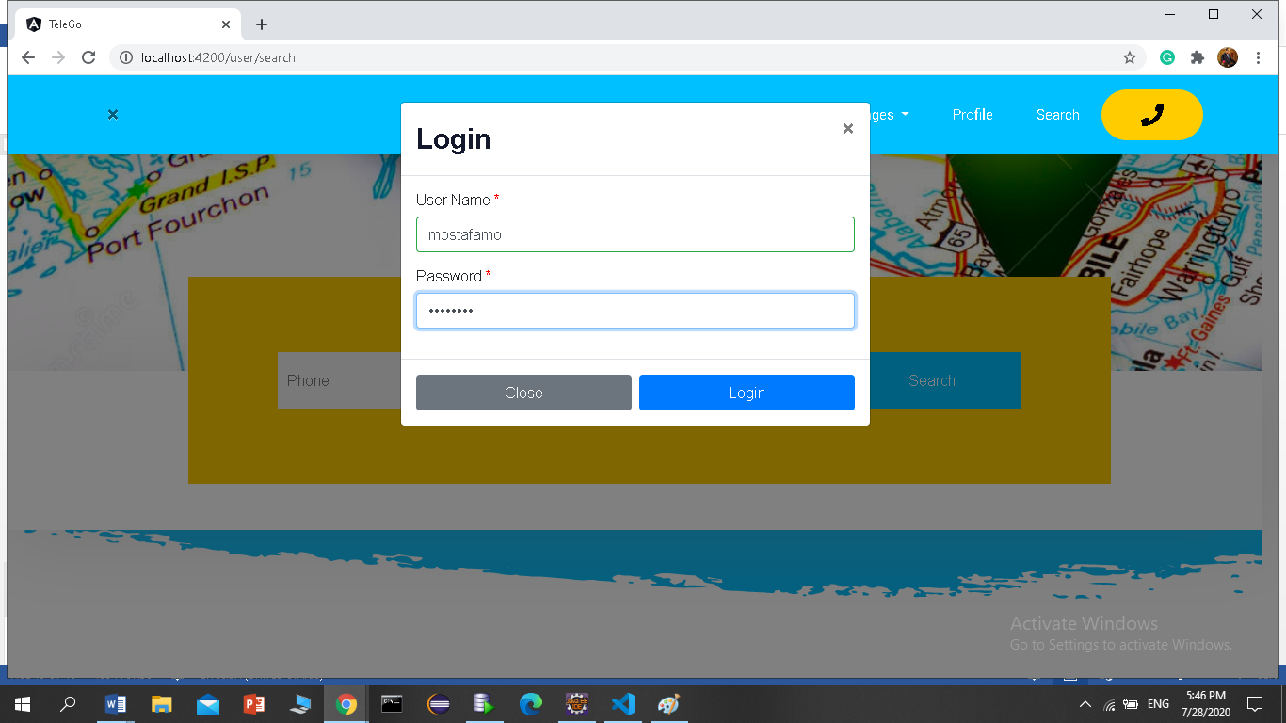

Figure 4.14 Login Form

**4.6.Admin control page**

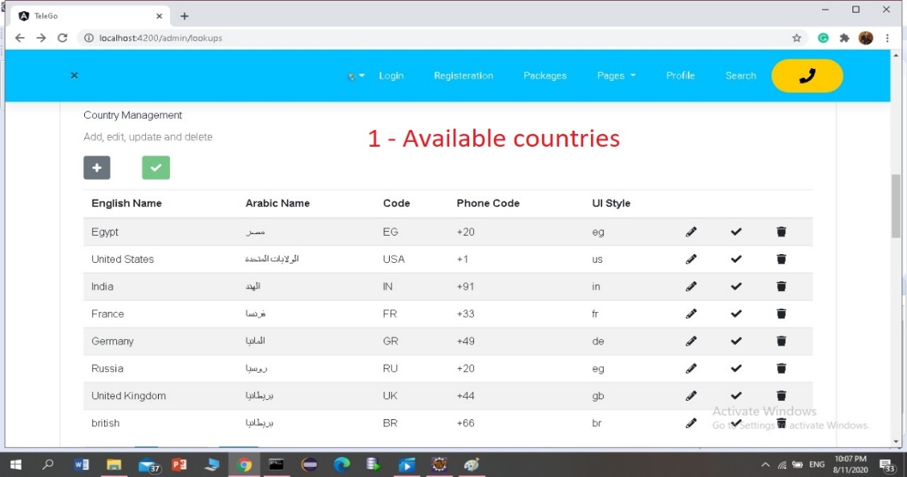

**Figure 4.15 Country management**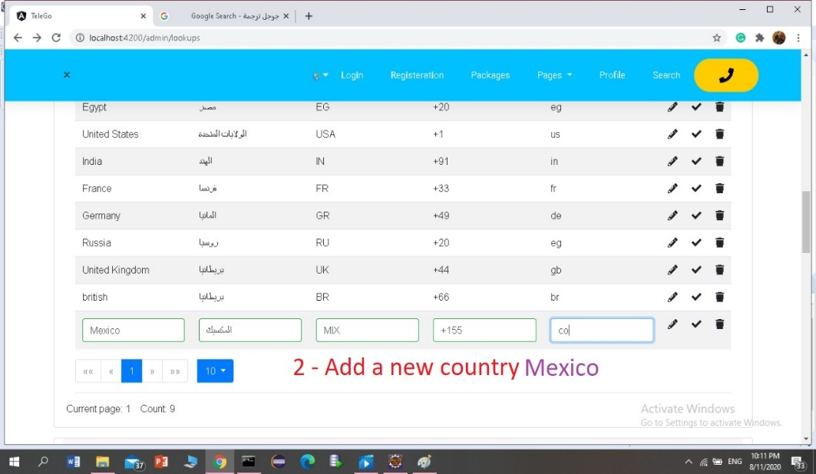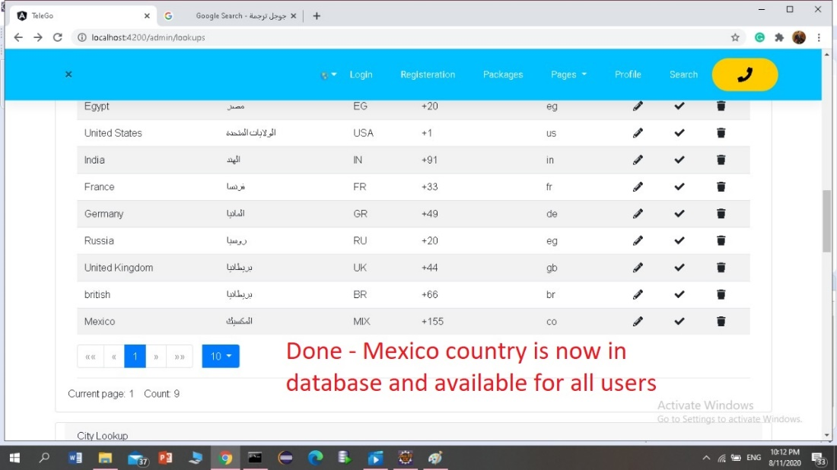

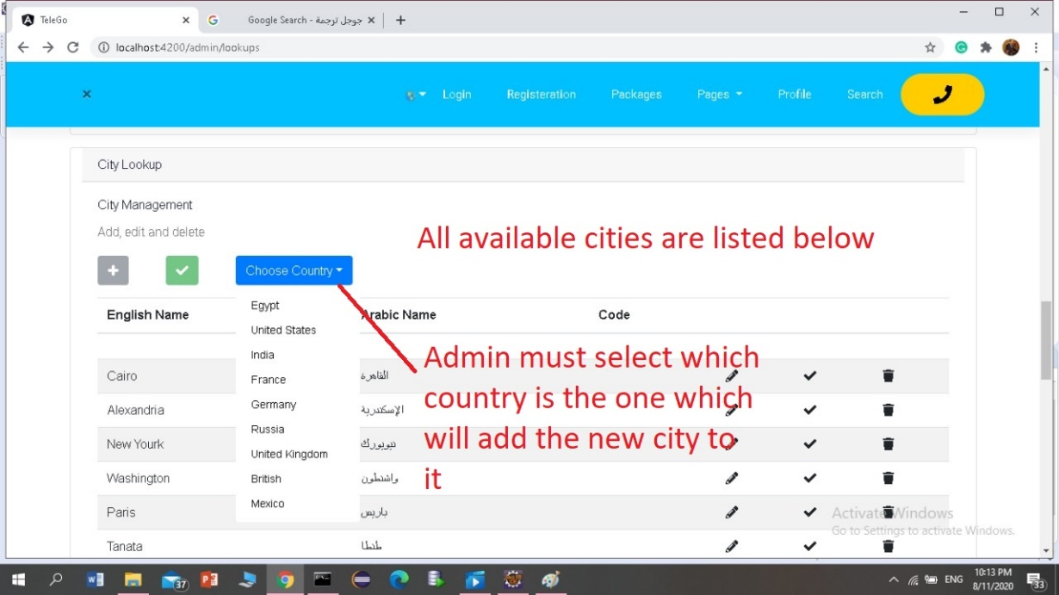

**Figure 4.16 City management**

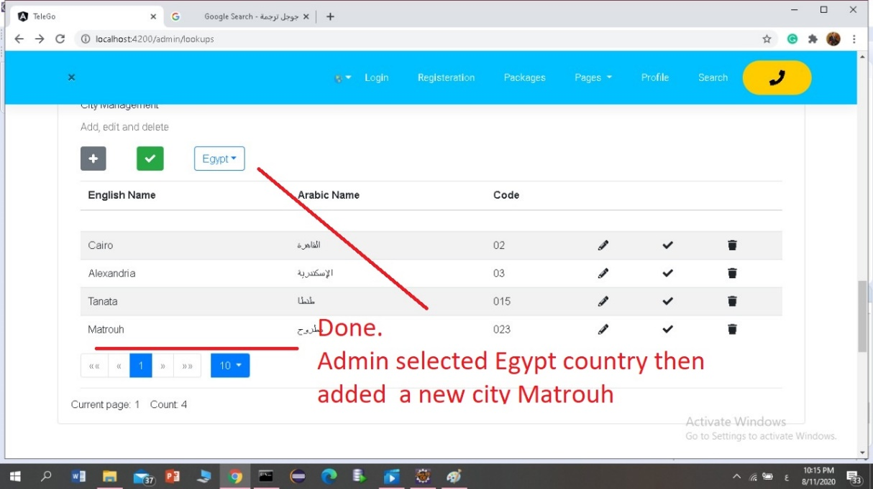

**4.3. Code**

Chapter 5

Conclusion and Future Work

* 1. **Conclusion**

We make web site that connects peoples, hospitals, police stations...etc., and make a facility to them to find the address or features The site is also secured by

1. Only computers of authorized organizations can enter to the site with its mac addresses.

2. Only authorized users can log in to the system.

3. Password for all users generated and changed monthly and sent to their emails.

There are forms for out access to the system by citizens or volunteers, which can reporting about any missing data or features. There is a help for each kind of site users appears on his forms. Awareness (global and periodically) both included in our site.

**5.2. Future work**

1. Implementing Drop Point delivery.

**5.3. References**

1. Gamale, J., Anuta, E., SaysonZ. (2012) Automated Class Scheduling System, Bohol Island State University, Main Campus.

2. Paulus, J. (2008). Online Scheduling and Project Scheduling. University of Twente.

3. Sing Sandhu, K. Automating Class Schedule Generation in the Context of a University.

4. Guttierez, Kenedy, R. (2010). PREFERENCE DRIVEN UNIVERSISTY COURSE SCHEDULINGSYSTEM, California Polytechnic State University.

5. Timetabling Information System, MBA School of Management, Nathan Campus, and Griffith University.

6. Wikipedia

https://en.wikipedia.org/wiki/Timetable